**Linux/Unix Tutorial for Beginners:**

**Training Summary**

Linux is the most popular server OS. Linux is a clone of UNIX. Knowing one is as good as knowing the other. In this tutorial series, we will be using Linux as it's freely available. The training will require you to execute certain commands. Make sure to practice them!

**What should I know?**

Nothing. This tutorial is for absolute beginner's guide to Linux. You don't even have to buy a new PC to learn Linux. You can run Linux, right within your existing Windows or Mac OS systems! (Detailed steps are given in tutorials).

## Syllabus

**Linux Fundamentals**

|  |  |
| --- | --- |
| [**Tutorial**](https://www.guru99.com/introduction-linux.html) | Introduction to the Linux Operating System |
| [**Tutorial**](https://www.guru99.com/install-linux.html) | Linux Distributions & Installation |
| [**Tutorial**](https://www.guru99.com/linux-differences.html) | Linux Vs. Windows |
| [**Tutorial**](https://www.guru99.com/terminal-file-manager.html) | Terminal V/s File Manager |

**Getting Started**

|  |  |
| --- | --- |
| [**Tutorial**](https://www.guru99.com/must-know-linux-commands.html) | Must Know Linux/Unix Commands |
| [**Tutorial**](https://www.guru99.com/file-permissions.html) | File Permissions in Linux/Unix |

**Advance Stuff!**

|  |  |
| --- | --- |
| [**Tutorial**](https://www.guru99.com/linux-redirection.html) | Redirection in Linux/Unix |
| [**Tutorial**](https://www.guru99.com/linux-pipe-grep.html) | Linux/Unix Pipes, Grep & Sort Command |
| [**Tutorial**](https://www.guru99.com/linux-regular-expressions.html) | Linux - Regular Expressions |

**Know the OS!**

|  |  |
| --- | --- |
| [**Tutorial**](https://www.guru99.com/linux-environment-variables.html) | Linux - Environment Variables |
| [**Tutorial**](https://www.guru99.com/communication-in-linux.html) | Communication in Linux |
| [**Tutorial**](https://www.guru99.com/managing-processes-in-linux.html) | Managing Processes in Linux |
| [**Tutorial**](https://www.guru99.com/the-vi-editor.html) | The VI Editor |

**Let's Code!**

|  |  |
| --- | --- |
| [**Tutorial**](https://www.guru99.com/introduction-to-shell-scripting.html) | Introduction to Shell Scripting |
| [**Tutorial**](https://www.guru99.com/unix-virtual-terminal.html) | Unix - Virtual Terminal |
| [**Tutorial**](https://www.guru99.com/linux-admin.html) | Unix/Linux Administration |
| [**Tutorial**](https://www.guru99.com/difference-unix-vs-linux.html) | Unix Vs. Linux: What’s the Difference? |
| [**Tutorial**](https://www.guru99.com/best-linux-certifications.html) | Best Linux Certifications: RHCE, LPI, CompTIA, Linux Foundation, Oracle |
| [**Tutorial**](https://www.guru99.com/shell-scripting-interview-questions.html) | Top 50 Shell Scripting Interview Questions & Answers |
| [**Tutorial**](https://www.guru99.com/linux-interview-questions-answers.html) | Top 60 Linux Interview Questions & Answers |
| [**Tutorial**](https://www.guru99.com/unix-interview-questions.html) | Top 50 Unix Interview Questions & Answers |
| [**Tutorial**](https://www.guru99.com/linux-tutorial-pdf.html) | Linux Tutorial for Beginners PDF |

# Introduction to the Linux Operating System

Before we learn Linux, let’s understand-

## What is an Operating System?

Every time you switch on your computer, you see a screen where you can perform different activities like write, browse the internet or watch a video. What is it that makes the computer hardware work like that? How does the processor on your computer know that you are asking it to run a mp3 file?

Well, it is the operating system or the kernel which does this work. A kernel is a program at the heart of any operating system that takes care of fundamental stuff, like letting hardware communicate with software.

So, to work on your computer, you need an Operating System(OS). In fact, you are using one as you read this on your computer. Now, you may have used popular OS's like Windows, Apple OS X but here we will learn what Linux is and what benefits it offers over other OS choices.

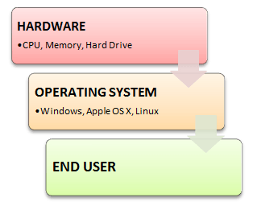

## What is Linux?

Linux is an operating system or a kernel. It is distributed under an open source license. Its functionality list is quite like UNIX.

## Who created Linux?



Linux is an operating system or a kernel which germinated as an idea in the mind of young and bright **Linus Torvalds** when he was a computer science student. He used to work on the **UNIX OS (proprietary software)**and thought that it needed improvements.

However, when his suggestions were rejected by the designers of UNIX, he thought of launching an OS which will be **receptive to changes, modifications suggested by its users**.

What is Linux? :Linux Beginner Tutorial

Below is the Video url: <https://youtu.be/xRX6ZI_P-LA>

## The Lone Kernel & the early days

So **Linus devised a Kernel** named Linux in 1991. Though he would need programs like File Manager, Document Editors, Audio -Video programs to run on it. Something as you have a cone but no ice-cream on top.

As time passed by, he collaborated with other **programmers in places like MIT** and applications for Linux started to appear. So around 1991, a working Linux operating system with some applications was officially launched, and this was the start of one of the **most loved and open-source OS options available today**.

The earlier versions of Linux were not so user-friendly as they were in use by computer programmers and **Linus Torvalds never had it in mind to commercialize** his product.

This definitely curbed the Linux's popularity as other commercially oriented Operating System Windows got famous. Nonetheless, the open-source aspect of the Linux operating system made it more robust.

## Linux gets its due attention

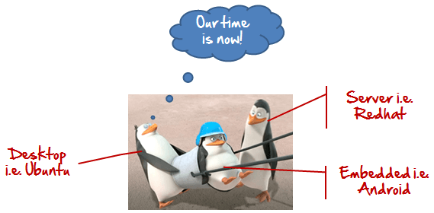

The main advantage of Linux was that programmers were able to use the Linux Kernel to design their own custom operating systems. With time, a new range of user-friendly OS's stormed the computer world. Now, **Linux is one of the most popular and widely used Kernel,**and it is the backbone of popular operating systems like **Debian, Knoppix, Ubuntu, and Fedora**. Nevertheless, the list does not end here as there are thousands of OS's based on Linux which offer a variety of functions to the users.

Linux Kernel is normally used in combination of [GNU](https://www.gnu.org/gnu/linux-and-gnu.html) project by Dr. Richard Stallman. All mordern distributions of Linux are actually distributions of Linux/GNU

## The benefits of using Linux

Linux now enjoys popularity at its prime, and it's famous among programmers as well as regular computer users around the world. Its main benefits are -

It offers a **free operating system**. You do not have to shell hundreds of dollars to get the OS like Windows!

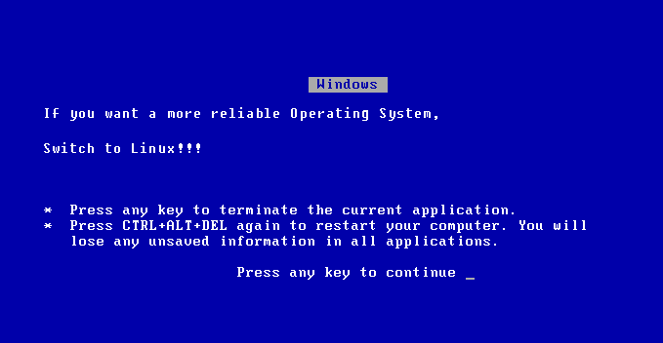

* Being open-source, anyone with programming knowledge can modify it.
* The Linux operating systems now offer **millions of programs/applications to choose from**, most of them free!
* Once you have Linux installed you no longer need an antivirus! Linux is a highly secure system. More so, there is a global development community constantly looking at ways to enhance its security. With each upgrade, the OS becomes more secure and robust
* Linux is the OS of choice for Server environments due to its stability and reliability (Mega-companies like Amazon, Facebook, and Google use Linux for their Servers). A Linux based server could run non-stop without a reboot for years on end.

## Is it for me?



Users, who are new to Linux, usually shun it by falsely considering it as a difficult and technical OS to operate but, to state the truth, in the last few years Linux operating systems have become a lot more user-friendly than their counterparts like Windows**,** so trying them is the best way to know whether Linux suits you or not.

There are **thousands of Linux based operating systems;** most of them offer **state-of-the-art security and applications**,**all of it for free!**

This is what Linux is all about, and now we will move on to how to install Linux and which Distribution you should choose.

## I am asked to Learn Unix? Then why Linux?

UNIX is called the mother of operating systems which laid out the foundation to Linux. Unix is designed mainly for mainframes and is in enterprises and universities. While Linux is fast becoming a household name for computer users, developers, and server environment. You may have to pay for a Unix kernel while in Linux it is free.

But, the **commands used on both the operating systems are usually the same.** There is not much difference between UNIX and Linux. Though they might seem different, at the core, they are essentially the same. Since **Linux is a clone of UNIX**. So learning one is same as learning another.

# How to Download & Install Linux (Ubuntu) in Windows

Now that we know what Linux is, it is the time that to learn how we should install it on the computer and choose which Distribution we should use. Let us start by understanding what a Linux Distribution is.

In this tutorial, we will learn -

* [What is a Linux Distribution?](https://www.guru99.com/install-linux.html#1)
* [How many distributions are out there?](https://www.guru99.com/install-linux.html#2)
* [The Best Linux Distribution!](https://www.guru99.com/install-linux.html#3)
* [Installing Linux using USB stick](https://www.guru99.com/install-linux.html#4)
* [Installing Linux using CD-ROM](https://www.guru99.com/install-linux.html#5)
* [Installing Linux using Virtual Machine](https://www.guru99.com/install-linux.html#6)

## What is a Linux Distribution?

Well, now as you know that **Linux is open-source, free to use kernel**. It is used by programmers, organizations, profit and non-profit companies around the world to **create Operating systems to suit their individual requirements**.

To prevent hacking attempts, many organizations keep their Linux operating systems private.

Many others make their variations of Linux available publicly so the whole world can benefit at large.

These versions/ types /kinds of **Linux operating system are called Distributions**.

Look at this Video: <https://youtu.be/ybHxztXXE-4>

### How many distributions are out there?



There are **hundreds of Linux operating systems or Distributions**available these days. Many of them are designed with a specific purpose in mind. For example, to run a **web server or to run on network switches like routers, modems,**etc.

The latest example of one of the most popular smartphone-based **Linux Distribution is Android!**

Many of these Distributions are built to offer **excellent personal computing**.

Here, are a few popular Linux Distributions (also called Linux Distro) -

| **Linux Distribution** | **Name** | **Description** |
| --- | --- | --- |
| <https://www.guru99.com/images/ArchLinux.png> | **Arch** | This Linux Distro is popular amongst Developers. It is an independently developed system. It is designed for users who go for a do-it-yourself approach. |
| <https://www.guru99.com/images/centos.png> | **CentOS** | It is one of the most used Linux Distribution for enterprise and web servers. It is a free enterprise class Operating system and is based heavily on Red Hat enterprise Distro. |
| <https://www.guru99.com/images/debian.png> | **Debian** | Debian is a stable and popular non-commercial Linux distribution. It is widely used as a desktop Linux Distro and is user-oriented. It strictly acts within the Linux protocols. |
| <https://www.guru99.com/images/fedora.png> | **Fedora** | Another Linux kernel based Distro, Fedora is supported by the Fedora project, an endeavor by Red Hat. It is popular among desktop users. Its versions are known for their short life cycle. |
| <https://www.guru99.com/images/gentoo.png> | **Gentoo** | It is a source based Distribution which means that you need to configure the code on your system before you can install it. It is not for Linux beginners, but it is sure fun for experienced users. |
| <https://www.guru99.com/images/LinuxMint.png> | **LinuxMint** | It is one of the most popular Desktop Distributions available out there. It launched in 2006 and is now considered to be the fourth most used Operating system in the computing world. |
| <https://www.guru99.com/images/OpenSuse.png> | **OpenSUSE** | It is an easy to use and a good alternative to MS Windows. It can be easily set up and can also run on small computers with obsolete configurations. |
| <https://www.guru99.com/images/redhat(2).png> | **RedHat enterprise** | Another popular enterprise based Linux Distribution is Red Hat Enterprise.It has evolved from Red Hat Linux which was discontinued in 2004. It is a commercial Distro and very popular among its clientele. |
| <https://www.guru99.com/images/slackware.png> | **Slackware** | Slackware is one of the oldest Linux kernel based OS's. It is another easy desktop Distribution. It aims at being a 'Unix like' OS with minimal changes to its kernel. |
| <https://www.guru99.com/images/ubuntu_logo.png> | **Ubuntu** | This is the third most popular desktop operating system after Microsoft Windows and Apple Mac OS. It is based on the Debian Linux Distribution, and it is known as its desktop environment. |

### The Best Linux Distribution!

The term best is **relative. Each Linux distribution is built for a specific purpose-built to meet the demands of its target users.**

The desktop Distributions are **available for free** on their respective websites. You might want to try them one by one till you get to know which Distribution you like the most. Each one of them offers its own unique design, **applications**, and **security**.

We will be using Ubuntu for our learning purpose as it's easy for a beginner to understand.

## Installing Linux

Let's look the various methods we can use to install Ubuntu.

### Installing Linux using USB stick

This is one of the easiest methods of installing Ubuntu or any distribution on your computer. Follow the steps.

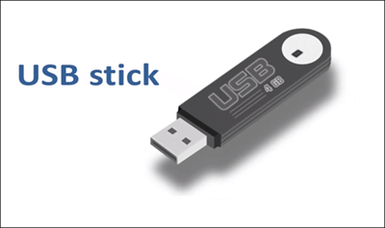

**Step 1)** Download the .iso or the OS files on your computer from this [link](http://www.ubuntu.com/download/desktop).

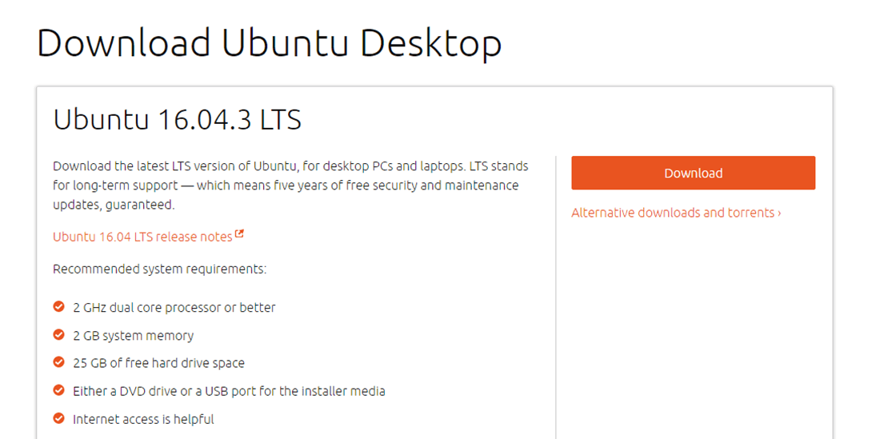

**Step 2)** Download free software like '[Universal USB installer](http://www.pendrivelinux.com/universal-usb-installer-easy-as-1-2-3/) to make a bootable USB stick.

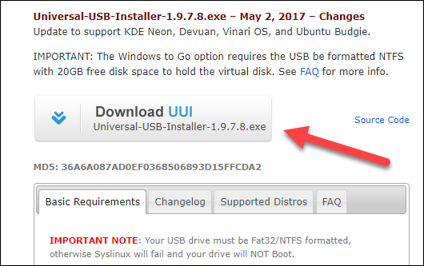

**Step 3)**Select an Ubuntu Distribution form the dropdown to put on your USB

Select your Ubuntu iso file download in step 1.

Select the drive letter of USB to install Ubuntu and Press create button.

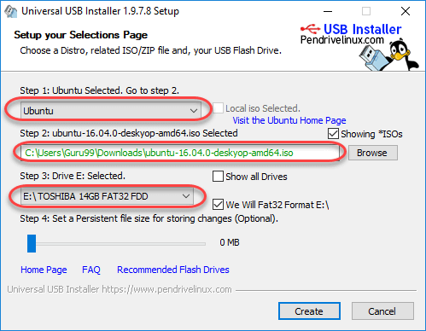

**Step 4)**Click YES to Install Ubuntu in USB.

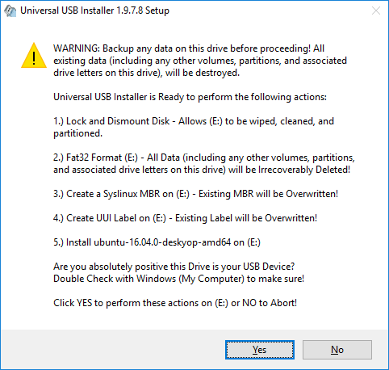

**Step 5)**After everything has been installed and configured, a small window will appear Congratulations! You now have Ubuntu on a USB stick, bootable and ready to go.

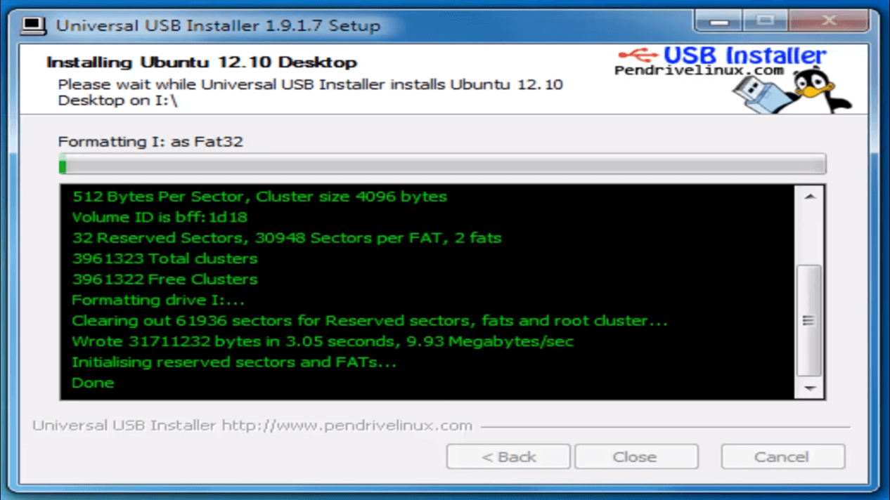

### Installing Linux using CD-ROM

Those who like the way a CD runs should try using this method.

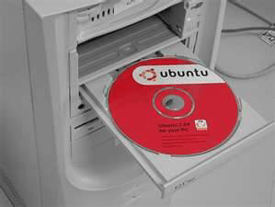

**Step 1)**Download the .iso or the OS files onto your computer from this link <http://www.ubuntu.com/download/desktop>.

**Step 2)**Burn the files to a CD.

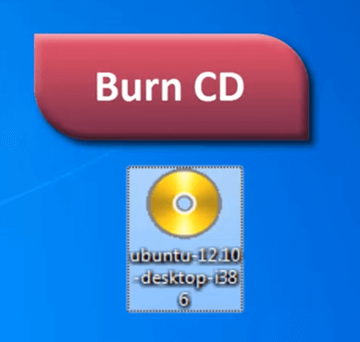

**Step 3)**Boot your computer from the optical drive and follow the instructions as they come.

### Installing Linux using Virtual Machine

This is a popular method to install a Linux operating system. The virtual installation offers you the freedom of running Linux on an existing OS already installed on your computer. This means if you have Windows running, then you can just run Linux with a click of a button.

Virtual machine software like Oracle VM can install Ubuntu in easy steps. Let us look at them.

**Here the brief steps**



**PART A) Download and Install Virtual Box**

Download Virtual box using this [link](https://www.virtualbox.org/wiki/Downloads)

Depending on your processor and OS, select the appropriate package. In our case, we have selected Windows with AMD

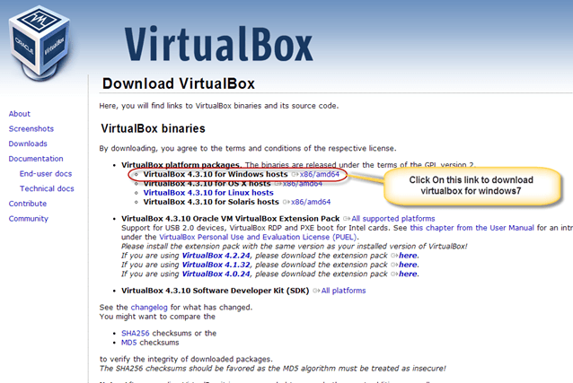

Once the download is complete, Open setup file and follow the steps below:

**Step-1)**Click On next

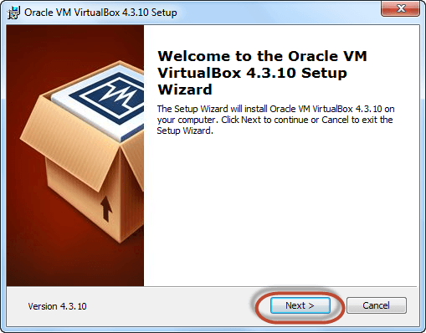

**Step-2)**Select you're the directory to install VirtualBox and click on next

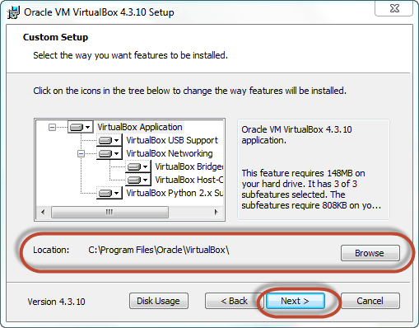

**Step-3)**Select Desktop icon and click on next, now click on yes

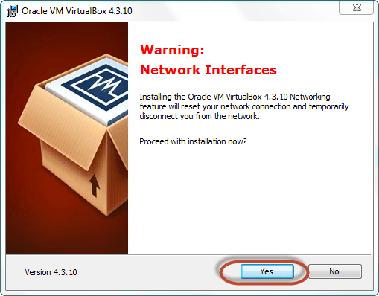

**Step-4)**Click On install.

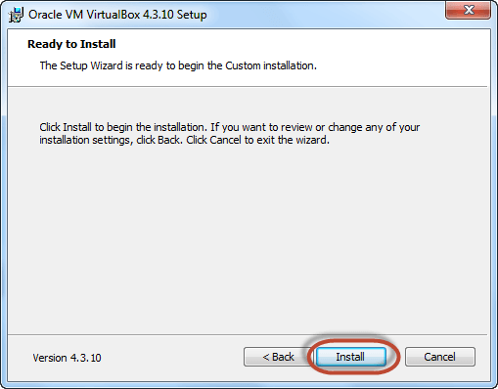

**Step-5)**Now installation of the virtual box will start. Once complete, click on Finish Button to start Virtual Box

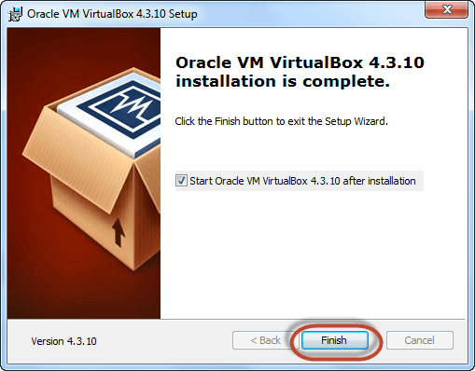

The virtual box dashboard looks like this-

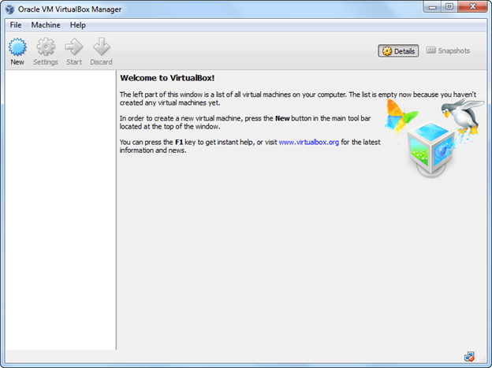

**PART B) Download Ubuntu**

Visit this link to [download](http://www.ubuntu.com/download/desktop) Ubuntu.

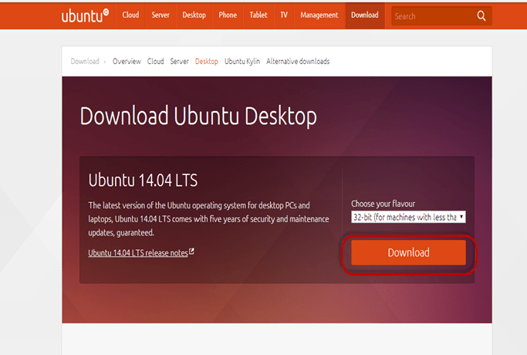

You can select 32/64-bit versions as per your choice.

**PART C) Create a Machine in Virtual Box**

**Step-1)**Open Virtual box and click on new button

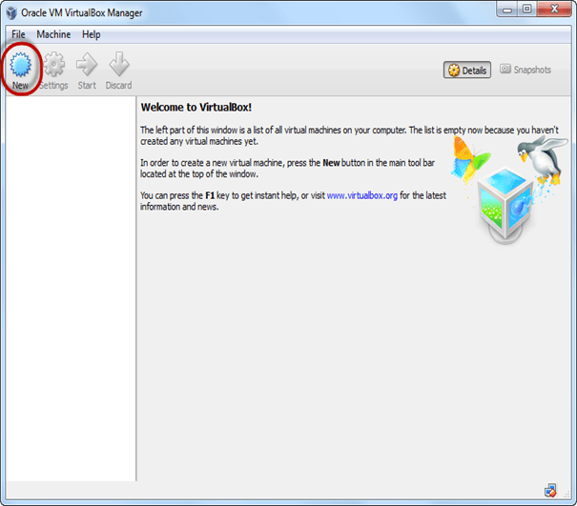

**Step-2)**In next window**,**give the name of your OS which you are installing in virtual box. And select OS like[Linux](https://www.guru99.com/unix-linux-tutorial.html)and version as Ubuntu 32 bit. And click on next

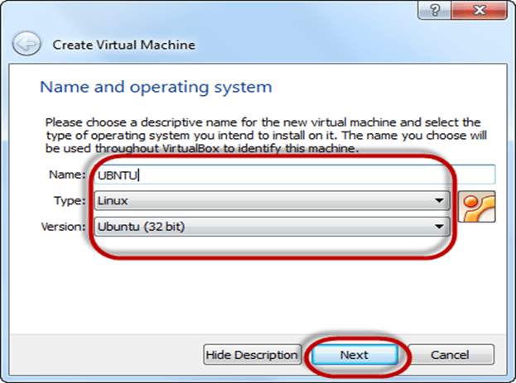

**Step-3)**Now Allocate Ram Size To your Virtual OS. I recommended keeping 1024mb (1 GB) ram to run Ubuntu better. And click on next.

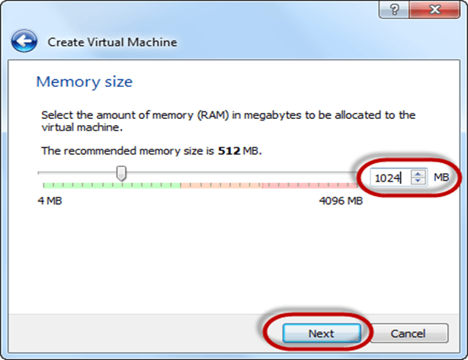

**Step-4)**Now To run OS in virtual box we have to create virtual hard disk, click on create a virtual hard drive now and click on create button.

The virtual hard disk is where the OS installation files and data/applications you create/install in this Ubuntu machine will reside

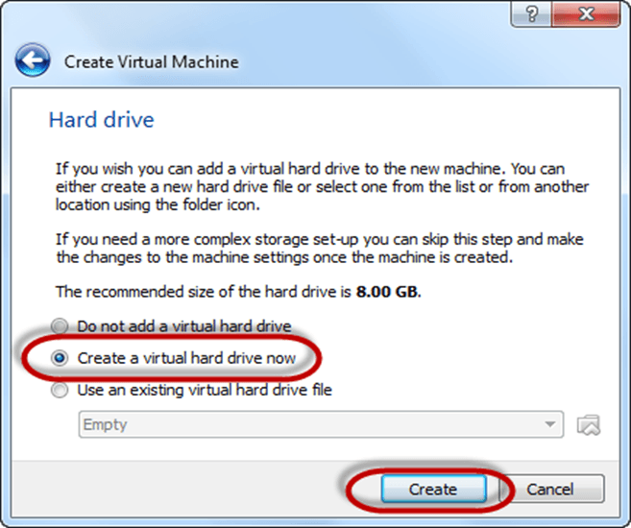

**Step-5)**select VHD (virtual hard disk) option and click on next.

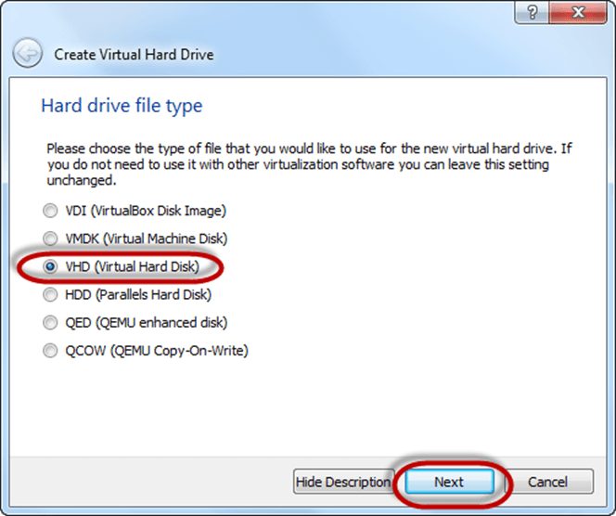

**Step-6)**Click on dynamic allocated and click on next. This means that the size of the disk will increase dynamically as per requirement.

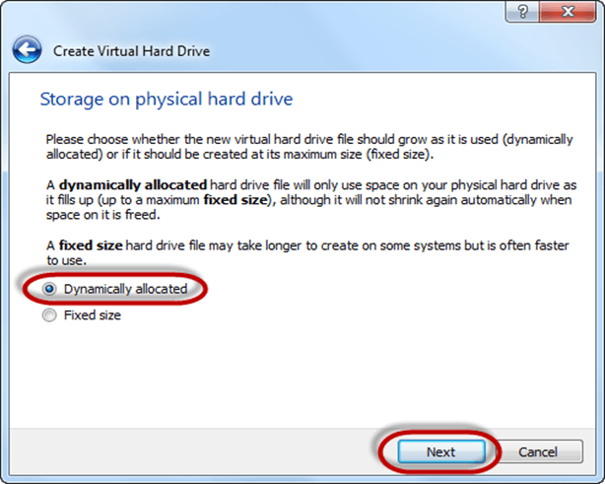

**Step-7)**Allocate memory to your virtual hard drive .8GB recommended. Click on create button.

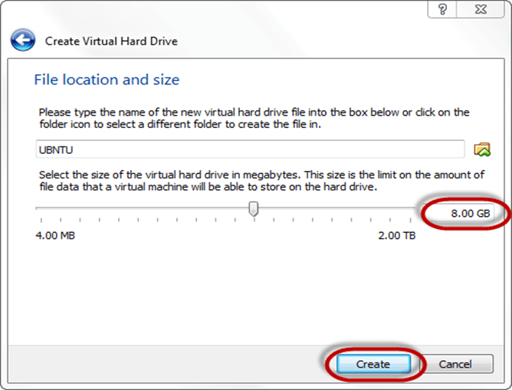

**Step-8)**Now you can see the machine name in left panel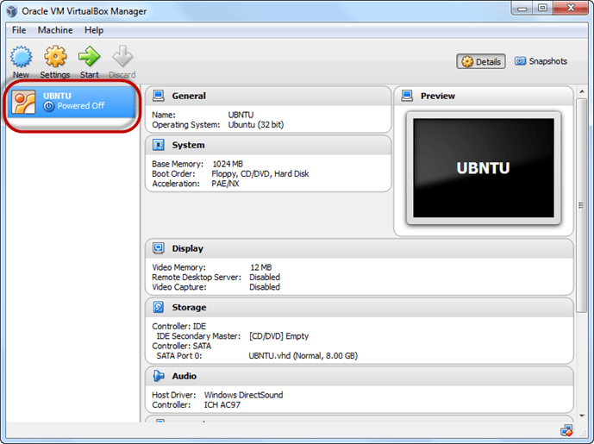So a Machine (PC) with 8GB Hardisk, 1GB RAM is ready.

**PART D) Install Ubuntu on the Machine**

**Step 1**) Select the Machine and Click on Start

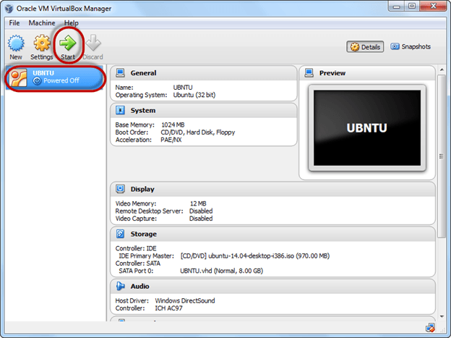

**Step 2)** Select the Folder Option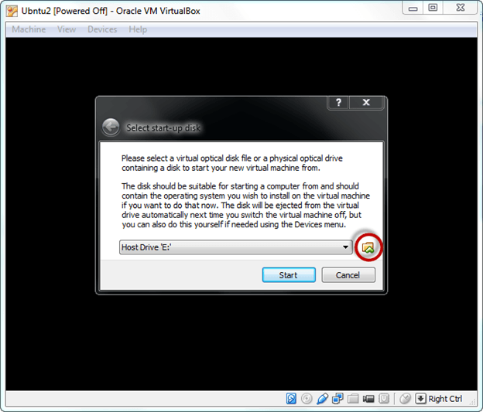

**Step 3)** Select the Ubuntu iso file

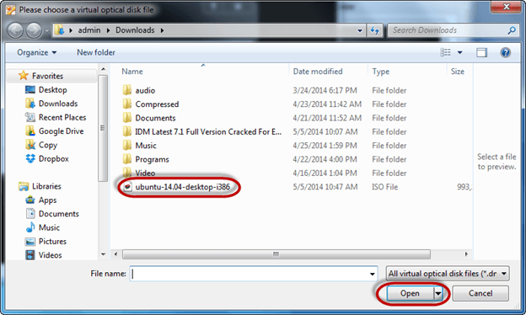

**Step 4)** Click Start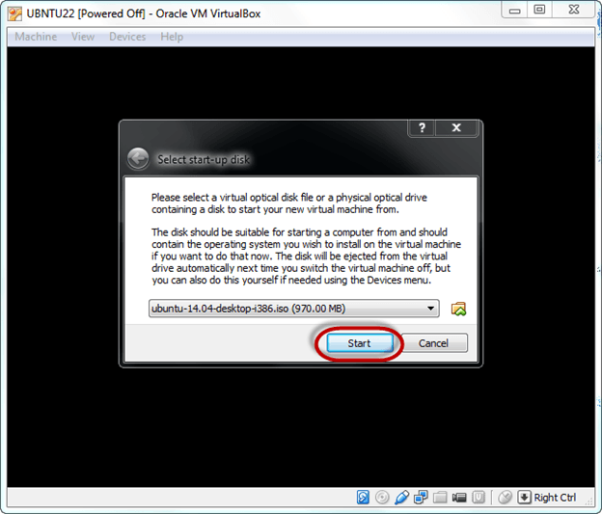**Step-5)**You have an option to Run Ubuntu WITHOUT installing. In this tutorial will install Ubuntu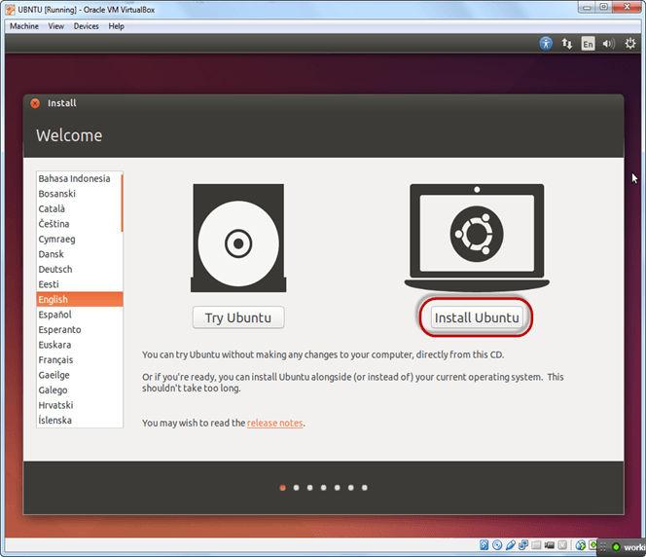

**Step-6)** Click continue.

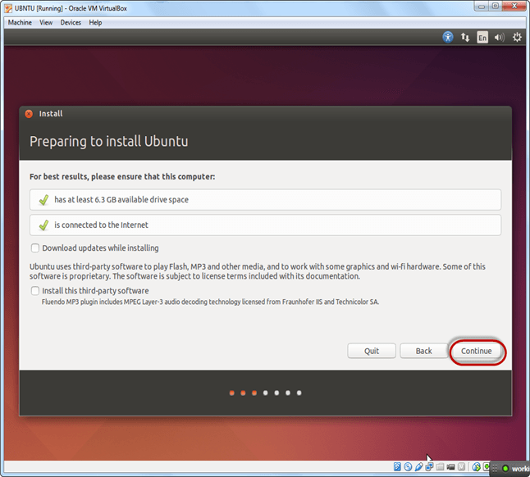

**Step-7)**Select option to erase the disk and install Ubuntu and click on install now. This option installs Ubuntu into our virtual hard drive which is we made earlier. It will not harm your PC or Windows installation

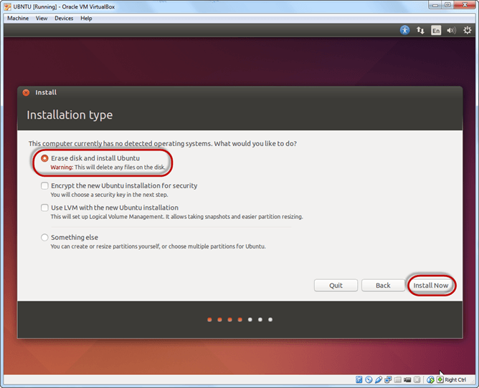

**Step-8)**Select your location for setting up time zone, and click on continue

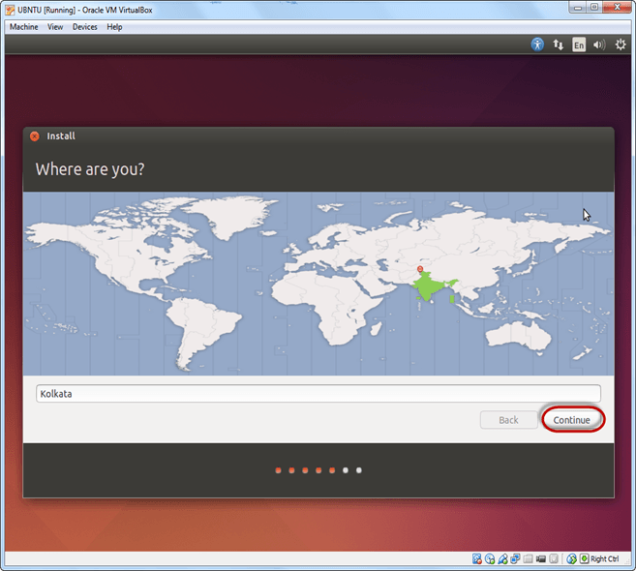

**Step-9)**Select your keyboard layout, by default English (US) is selected but if you want to change then, you can select in the list. And click on continue

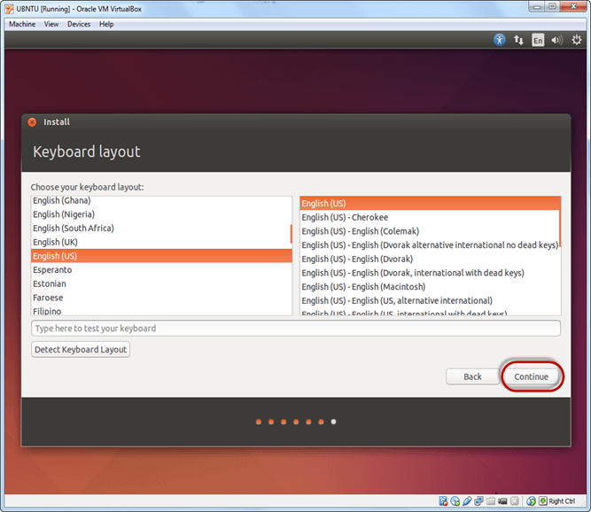

**Step-10)**Select your username and password for your Ubuntu admin account. This information has been needed for installing any software package into Ubuntu and also for login to your OS. Fill up your details and tick on login automatically to ignore login attempt and click on continue

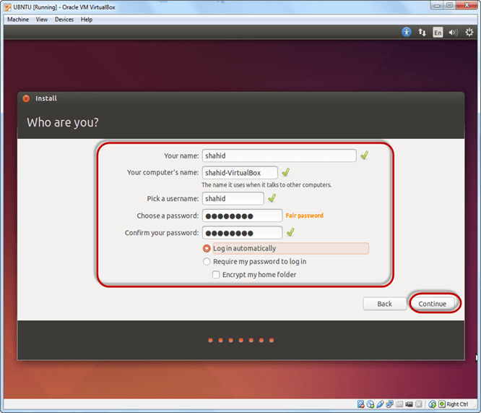

**Step-11)**Installation process starts. May take up to 30 minutes. Please wait until installation process completes. 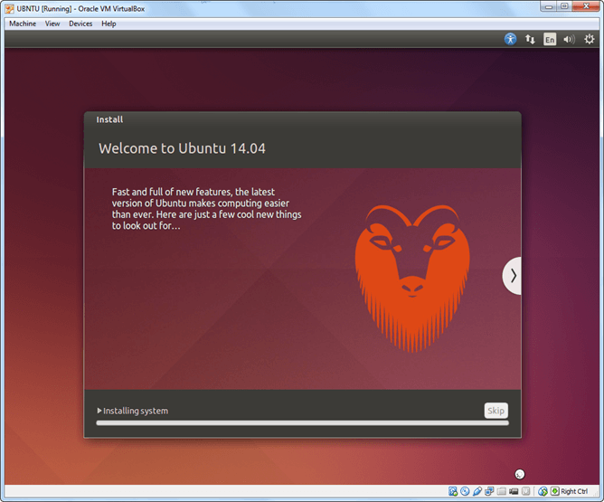

**Step-12)**After finishing the installation, you will see Ubuntu Desktop.

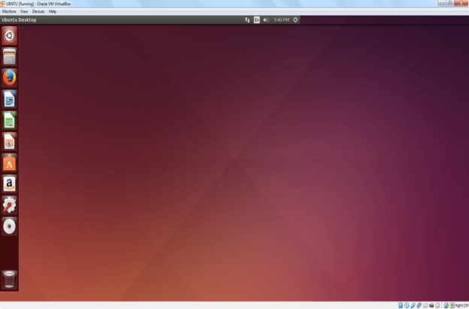

**Summary**

* An operating system based on the Linux kernel is called a Distribution or Distro
* There are hundreds of Distributions available, some of which are designed to accomplish a sole purpose like running servers, act as network switches, etc.
* Naming the best Linux Distribution is difficult as they are made for different.
* Linux can be installed on your system via the below-mentioned methods:
  + USB stick
  + Live CD
  + Virtual Installation

# Linux vs Windows: What's the Difference?

It's time to make the big switch from your Windows or Mac OS operating system.

Mac OS uses a UNIX core. Your switch from Mac OS to Linux will be relatively smooth.

It's the Windows users who will need some adjusting. In this tutorial will introduce the Linux OS and compare it with Windows.

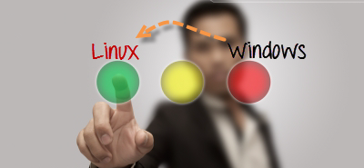

In this tutorial will introduce the Linux OS and compare it with Windows.

* [Windows Vs. Linux: File System](https://www.guru99.com/linux-differences.html#1)
* [Linux Types of Files](https://www.guru99.com/linux-differences.html#2)
* [Windows Vs. Linux: Users](https://www.guru99.com/linux-differences.html#3)
* [Windows Vs. Linux: File Name Convention](https://www.guru99.com/linux-differences.html#4)
* [Windows Vs. Linux: HOME Directory](https://www.guru99.com/linux-differences.html#5)
* [Windows Vs. Linux: Other Directories](https://www.guru99.com/linux-differences.html#6)
* [Windows Vs. Linux: Key Differences](https://www.guru99.com/linux-differences.html#7)

<https://youtu.be/JijVGIR2n8E>

## Windows Vs. Linux File System

In Microsoft Windows, files are stored in folders on different data drives like C: D: E:

But, in **Linux, files are ordered in a tree structure starting with the root directory**.

This root directory can be considered as the start of the file system, and it further branches out various other subdirectories. The root is denoted with a forward slash '/'.

A general tree file system on your UNIX may look like this.

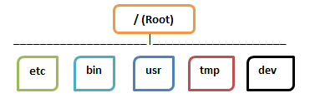

## Types of Files

In Linux and UNIX, everything is a file. Directories are files, files are files, and devices like Printer, mouse, keyboard etc.are files.

Let's look into the File types in more detail.

### General Files

General Files also called as Ordinary files. They can contain image, video, program or simply text. They can be in ASCII or a Binary format. These are the most commonly used files by Linux Users.

### Directory Files

These files are a warehouse for other file types. You can have a directory file within a directory (sub-directory).You can take them as 'Folders' found in Windows operating system.

### Device Files:

In MS Windows, devices like Printers, CD-ROM, and hard drives are represented as drive letters like G: H:. In Linux, there are represented as files.For example, if the first SATA hard drive had three primary partitions, they would be named and numbered as /dev/sda1, /dev/sda2 and /dev/sda3.

**Note**: All device files reside in the directory /dev/

All the above file types (including devices) have permissions, which allow a user to read, edit or execute (run) them. This is a powerful Linux/Unix feature. Access restrictions can be applied for different kinds of users, by changing permissions.

## Windows Vs. Linux: Users

There are 3 types of users in Linux.

1. Regular
2. Administrative(root)
3. Service

**Regular User**

A regular user account is created for you when you install Ubuntu on your system. All your files and folders are stored in /home/ which is your home directory. As a regular user, you do not have access to directories of other users.

**Root User**

Other than your regular account another user account called root is created at the time of installation. The root account is a **superuser** who can access restricted files, install software and has administrative privileges. Whenever you want to install software, make changes to system files or perform any administrative task on Linux; you need to log in as a root user. Otherwise, for general tasks like playing music and browsing the internet, you can use your regular account.

**Service user**

Linux is widely used as a Server Operating System. Services such as Apache, Squid, email, etc. have their own individual service accounts.  Having service accounts increases the security of your computer. Linux can allow or deny access to various resources depending on the service.

Note:

1. You will not see service accounts in Ubuntu Desktop version.
2. Regular accounts are called standard accounts in Ubuntu Desktop

In Windows, there are 4 types of user account types.

1. Administrator
2. Standard
3. Child
4. Guest

## Windows Vs. Linux: File Name Convention

In Windows, you cannot have 2 files with the same name in the same folder. See below -

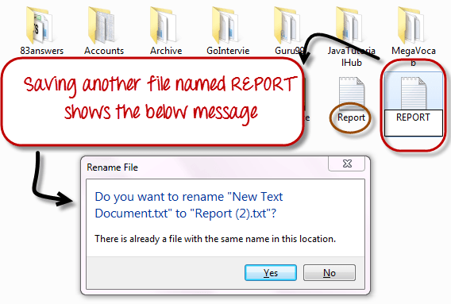

While in Linux, you can have 2 files with the same name in the same directory, provided they use different cases.

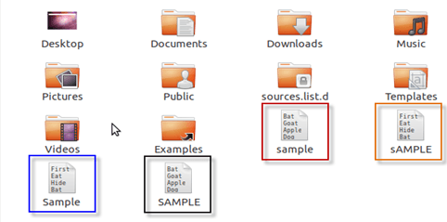

## Windows Vs. Linux: HOME Directory

For every user in Linux, a directory is created as **/home/**

Consider, a regular user account "Tom". He can store his personal files and directories in the directory "/home/tom". He can't save files outside his user directory and does not have access to directories of other users. For instance, he cannot access directory "/home/jerry" of another user account"Jerry".

The concept is similar to C:\Documents and Settings in Windows.

When you boot the Linux operating system, your user directory (from the above example /home/tom) is the **default working directory**. Hence the directory "/home/tom is also called the **Home directory** which is a misnomer.

The working directory can be changed using some commands which we will learn later.

## Windows Vs. Linux: Other Directories

In Windows, System and Program files are usually saved in C: drive. But, in Linux, you would find the system and program files in different directories. For example, the boot files are stored in the /boot directory, and program and software files can be found under /bin, device files in /dev. Below are important Linux Directories and a short description of what they contain.

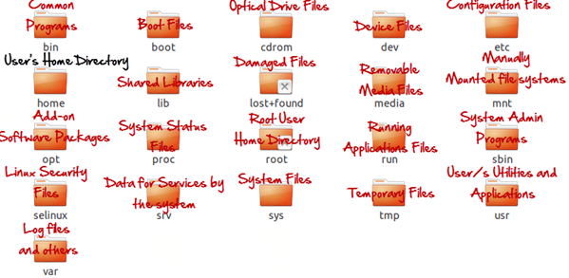These are most striking differences between Linux and other Operating Systems.  There are more variations you will observe when switching to Linux and we will discuss them as we move along in our tutorials.

## Windows Vs. Linux:

|  |  |
| --- | --- |
| **Windows** | **Linux** |
| Windows uses different data drives like C: D: E to stored files and folders. | Unix/Linux uses a tree like a hierarchical file system. |
| Windows has different drives like C: D: E | There are no drives in Linux |
| Hard drives, CD-ROMs, printers are considered as devices | Peripherals like hard drives, CD-ROMs, printers are also considered files in Linux/Unix |
| There are 4 types of user account types 1) Administrator, 2) Standard, 3) Child, 4) Guest | There are 3 types of user account types 1) Regular, 2) Root and 3) Service Account |
| Administrator user has all administrative privileges of computers. | Root user is the super user and has all administrative privileges. |
| In Windows, you cannot have 2 files with the same name in the same folder | Linux file naming convention is case sensitive. Thus, sample and SAMPLE are 2 different files in Linux/Unix operating system. |
| In windows, My Documents is default home directory. | For every user /home/username directory is created which is called his home directory. |

## KEY DIFFERENCE

* Linux is an open source operating system so user can change source code as per requirement whereas Windows OS is a commercial operating system so user doesn’t have access to source code.
* Linux is very well secure as it is easy to detect bugs and fix whereas Windows has a huge user base, so it becomes a target of hackers to attack windows system.
* Linux runs faster even with older hardware whereas windows are slower compared to Linux.
* Linux peripherals like hard drives, CD-ROMs, printers are considered files whereas Windows, hard drives, CD-ROMs, printers are considered as devices
* Linux files are ordered in a tree structure starting with the root directory whereas in Windows, files are stored in folders on different data drives like C: D: E:
* In Linux you can have 2 files with the same name in the same directory while in Windows, you cannot have 2 files with the same name in the same folder.
* In Linux you would find the system and program files in different directories whereas in Windows, system and program files are usually saved in C: drive.

# Linux Command Line Tutorial: Manipulate Terminal with CD Commands

The most frequent tasks that you perform on your PC is creating, moving or deleting Files. Let's look at various options for File Management.

To manage your files, you can either use

1. Terminal (Command Line Interface - CLI)
2. File manager (Graphical User Interface -GUI)

In this tutorial, you will learn-

* [Why learn Command Line Interface?](https://www.guru99.com/terminal-file-manager.html#1)
* [Launching the CLI on Ubuntu](https://www.guru99.com/terminal-file-manager.html#2)
* [Present working Directory (pwd)](https://www.guru99.com/terminal-file-manager.html#3)
* [Changing Directories (cd)](https://www.guru99.com/terminal-file-manager.html#4)
* [Navigating to home directory (cd ~)](https://www.guru99.com/terminal-file-manager.html#9)
* [Moving to root directory (cd /)](https://www.guru99.com/terminal-file-manager.html#5)
* [Navigating through multiple directories](https://www.guru99.com/terminal-file-manager.html#6)
* [Moving up one directory level (cd ..)](https://www.guru99.com/terminal-file-manager.html#7)
* [Relative and Absolute Paths](https://www.guru99.com/terminal-file-manager.html#8)

<https://youtu.be/G0LsYZ7Kwh8>

## Why learn Command Line Interface?

Even though the world is moving to GUI based systems, CLI has its specific uses and is widely used in scripting and server administration. Let's look at it some compelling uses -

* Comparatively, Commands offer more options & are flexible. Piping and stdin/stdout are immensely powerful are not available in GUI
* Some configurations in GUI are up to 5 screens deep while in a CLI  it's just a single command
* Moving, renaming 1000's of the file in GUI will be time-consuming (Using Control /Shift to select multiple files), while in CLI, using regular expressions so can do the same task with a single command.
* CLI load fast and do not consume RAM compared to GUI. In crunch scenarios this matters.

**Both GUI and CLI have their specific uses.** For example, **in GUI, performance monitoring graphs** give **instant visual feedback** on system health, while seeing hundreds of lines of logs in CLI is an eyesore.

You must learn to use both GUI(File Manager) and CLI (Terminal)

GUI of a Linux based OS is similar to any other OS. Hence, we will focus on CLI and learn some useful commands.

## Launching the CLI on Ubuntu

There are 2 ways to launch the terminal.

1) Go to the Dash and type terminal

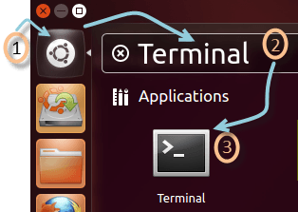

2) Or you can press **CTRL + Alt + T** to launch the Terminal

Once you launch the CLI (Terminal), you would find something as guru99@VirtualBox(see image) written on it.

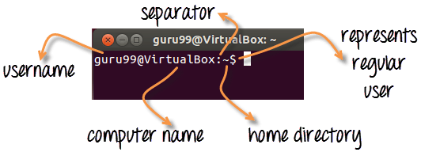

1) The first part of this line is the name of the **user** (bob, tom, ubuntu, home...)

2) The second part is the computer name or the host name. The hostname helps identify a computer over the network. In a server environment, host-name becomes important.

3) The **':'** is a simple separator

4) The tilde '~' sign shows that the user in working in the **home directory**. If you change the directory, this sign will vanish.

Terminal V/s File Manager &  The CD command

In the above illustration, we have moved from the /home directory to /bin using the **'cd' command**. The ~ sign does not display while working in /bin directory. It appears while moving back to the home directory.

5) The '$' sign suggests that you are working as a regular user in Linux. While working as a root user, '#' is displayed.

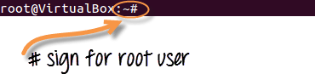

## Present Working Directory

The directory that you are currently browsing is called the Present working directory. You log on to the home directory when you boot your PC. If you want to determine the directory you are presently working on, use the command -

Pwd

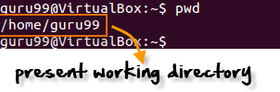

pwd command stands for **p**rint **w**orking **d**irectory

Above figure shows that /home/guru99 is the directory we are currently working on.

## Changing Directories

If you want to change your current directory use the '**cd**' command.

cd /tem

Consider the following example.

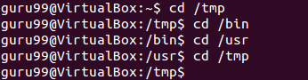

Here, we moved from directory /tmp to /bin to /usr and then back to /tmp.

## Navigating to home directory

If you want to navigate to the home directory, then type **cd**.

Terminal V/s File Manager &  The CD command

cd

You can also use the **cd ~** command.

[Terminal V/s File Manager &  The CD command](https://www.guru99.com/images/cd_.png)

cd ~

## Moving to root directory

The root of the file system in Linux is denoted by '/'. Similar to  'c:\' in Windows.

Note: In Windows, you use backward slash "\" while in UNIX/Linux, forward slash is used "/"

Type 'cd /' to move to the root directory.

cd /

[Terminal V/s File Manager &  The CD command](https://www.guru99.com/images/cd_root.png)

**TIP**: Do not forget space between **cd**and **/**. Otherwise, you will get an error.

## Navigating through multiple directories

You can navigate through multiple directories at the same time by specifying its complete path.

Example: If you want to move the /cpu directory under /dev, we do not need to break this operation in two parts.

Instead, we can type '/dev/cpu' to reach the directory directly.

cd /dev/cpu

[Terminal V/s File Manager &  The CD command](https://www.guru99.com/images/navigating_multiple.png)

## Moving up one directory level

For navigating up one directory level, try.

cd ..

Terminal V/s File Manager &  The CD command

Here by using the 'cd ..' command, we have moved up one directory from '/dev/cpu' to '/dev'.

Then by again using the same command, we have jumped from '/dev' to '/' root directory.

## Relative and Absolute Paths

A path in computing is the address of a file or folder.

Example - **In Windows**

C:\documentsandsettings\user\downloads

**In Linux**

/home/user/downloads

There are two kinds of paths:

### 1. Absolute Path:

Let's say you have to browse the images stored in the Pictures directory of the home folder 'guru99'.

The absolute file path of Pictures directory **/home/guru99/Pictures**

To navigate to this directory, you can use the command.

cd /home/guru99/Pictures

Terminal V/s File Manager &  The CD command

This is called absolute path as you are specifying the full path to reach the file.

### 2. Relative Path:

The Relative path comes in handy when you have to browse another subdirectory within a given directory.

It saves you from the effort to type complete paths all the time.

Suppose you are currently in your Home directory. You want to navigate to the Downloads directory.

You do no need to type the absolute path

cd /home/guru99/Downloads

Terminal V/s File Manager &  The CD command

Instead, you can simply type **'cd Downloads'**and you would navigate to the Downloads directory as you are already present within the **'/home/guru99'** directory.

cd Downloads

[Terminal V/s File Manager &  The CD command](https://www.guru99.com/images/relative_path_1.png)

This way you do not have to specify the complete path to reach a specific location within the same directory in the file system.

**Summary:**

* To manage your files, you can use either the GUI(File manager) or the CLI(Terminal) in Linux. Both have its relative advantages. In the tutorial series, we will focus on the CLI aka the Terminal
* You can launch the terminal from the dashboard or use the shortcut key **Cntrl + Alt + T**
* The pwd command gives the present working directory.
* You can use the cd command to change directories
* Absolute path is complete address of a file or directory
* Relative path is relative location of a file of directory with respect to current directory
* Relative path help avoid typing complete paths all the time.

|  |  |
| --- | --- |
| **Command** | **Description** |
| cd or cd ~ | Navigate to HOME directory |
| cd .. | Move one level up |
| cd | To change to a particular directory |
| cd / | Move to the root directory |

# Basic Linux/Unix Commands with Examples

File Management becomes easy if you know the right commands.

Sometimes, commands are also referred as "programs" since whenever you run a command, it's the corresponding program code, written for the command, which is being executed.

Let's learn the must know Linux commands.

**What You Will Learn:** [hide]

1. [Listing files (ls)](https://www.guru99.com/must-know-linux-commands.html#1)
2. [Listing Hidden Files](https://www.guru99.com/must-know-linux-commands.html#2)
3. [Creating & Viewing Files](https://www.guru99.com/must-know-linux-commands.html#3)
4. [Deleting Files](https://www.guru99.com/must-know-linux-commands.html#4)
5. [Moving and Re-naming files](https://www.guru99.com/must-know-linux-commands.html#5)
6. [Directory Manipulations](https://www.guru99.com/must-know-linux-commands.html#6)
7. [Removing Directories](https://www.guru99.com/must-know-linux-commands.html#7)
8. [Renaming Directory](https://www.guru99.com/must-know-linux-commands.html#8)
9. [The 'Man' command](https://www.guru99.com/must-know-linux-commands.html#9)
10. [The History Command](https://www.guru99.com/must-know-linux-commands.html#10)
11. [The clear command](https://www.guru99.com/must-know-linux-commands.html#11)
12. [Pasting commands into the terminal](https://www.guru99.com/must-know-linux-commands.html#12)
13. [Printing in Unix/Linux](https://www.guru99.com/must-know-linux-commands.html#13)
14. ['pr' command](https://www.guru99.com/must-know-linux-commands.html#14)
15. [Installing Software](https://www.guru99.com/must-know-linux-commands.html#15)
16. [Sending E-mails](https://www.guru99.com/must-know-linux-commands.html#16)
17. [Cheat Sheet](https://www.guru99.com/must-know-linux-commands.html#17)

<https://youtu.be/_TlK0-5EJ-Y?list=PLckPQEKYlbxebubMWdjcGR7K_ukm35ZjN>

## Listing files (ls)

If you want to see the list of files on your UNIX or Linux system, use the '**ls'** command.

It shows the files /directories in your current directory.

[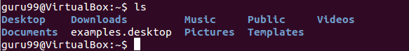](https://www.guru99.com/images/ls(1).png)

Note:

* Directories are denoted in blue color.
* Files are denoted in white.
* You will find similar color schemes in different flavors of Linux.

Suppose, your "Music" folder has following sub-directories and files.

[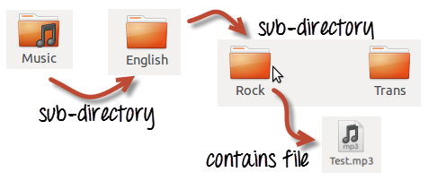](https://www.guru99.com/images/sub-directory(1).png)

You can use **'ls -R' to shows all the files not only in directories but also subdirectories**

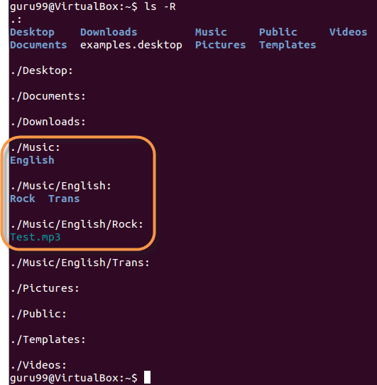

NOTE: The command is case-sensitive. If you enter, "**ls - r**" you will get an error.

**'ls -al'** gives detailed information of the files. The command provides information in a columnar format. The columns contain the following information:

|  |  |
| --- | --- |
| **1st Column** | **File type and access permissions** |
| **2nd Column** | # of HardLinks to the File |
| **3rd Column** | Owner and the creator of the file |
| **4th Column** | Group of the owner |
| **5th Column** | File size in Bytes |
| **6th Column** | Date and Time |
| **7th Column** | Directory or File name |

Let's see an example -

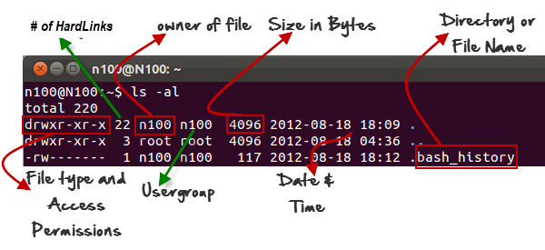

## Listing Hidden Files

Hidden items in UNIX/Linux begin with -[Must Know Linux/Unix Commands](https://www.guru99.com/images/period_symbol(2).png) at the start, of the file or directory.

Any Directory/file starting with a '.' will not be seen unless you request for it.  To view hidden files, use the command.

ls -a

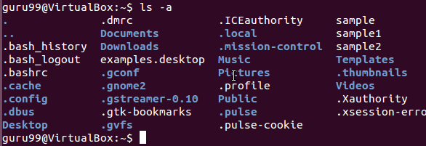

## Creating & Viewing Files

The 'cat' command is used to display text files. It can also be used for copying, combining and creating new text files.  Let's see how it works.

To create a new file, use the command

1. cat > filename
2. Add content
3. Press 'ctrl + d' to return to command prompt.

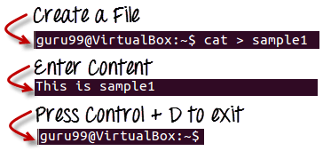

To view a file, use the command -

cat filename

Let's see the file we just created -

[Must Know Linux/Unix Commands](https://www.guru99.com/images/cat_view_a_file(1).png)

Let's see another file sample2

[Must Know Linux/Unix Commands](https://www.guru99.com/images/cat_sample2.png)

The syntax to combine 2 files is -

cat file1 file2 > newfilename

Let's combine sample 1 and sample 2.

[Must Know Linux/Unix Commands](https://www.guru99.com/images/cat_combine.png)

As soon as you insert this command and hit enter, the files are concatenated, but you do not see a result. This is because **Bash Shell (Terminal) is silent type**.  It will never give you a confirmation message like "OK" or "Command Successfully Executed". It will only show a message when something goes wrong or when an error has occurred.

To view the new combo file "sample" use the command

cat sample

[Must Know Linux/Unix Commands](https://www.guru99.com/images/cat_combo.png)

**Note:**Only text files can be displayed and combined using this command.

## Deleting Files

The 'rm' command removes files from the system without confirmation.

To remove a file use syntax -

rm filename

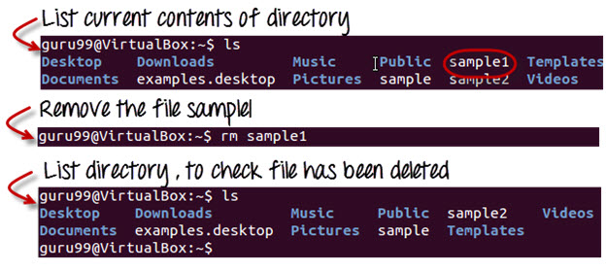

## Moving and Re-naming files

To move a file, use the command.

mv filename new_file_location

Suppose we want to move the file "sample2" to location /home/guru99/Documents. Executing the command

***mv sample2 /home/guru99/Documents***

[Must Know Linux/Unix Commands](https://www.guru99.com/images/mv_error.png)

mv command needs super user permission. Currently, we are executing the command as a standard user. Hence we get the above error. To overcome the error use command.

sudo command_you_want_to_execute

Sudo program allows regular users to run programs with the security privileges of the superuser or root.

Sudo command will ask for password authentication. Though, you do not need to know the root password. You can supply your own password. After authentication, the system will invoke the requested command.

Sudo maintains a log of each command run. System administrators can trackback the person responsible for undesirable changes in the system.

guru99@VirtualBox:~$ sudo mv sample2 /home/quru99/Documents

[sudo] password for guru99: ****

guru99@VirtualBox:~$

For renaming file:

mv filename newfilename

[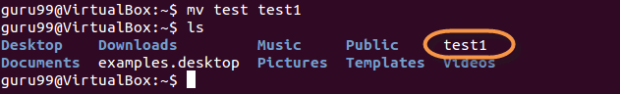](https://www.guru99.com/images/mv(1).png)

**NOTE**: By default, the password you entered for sudo is retained for 15 minutes per terminal. This eliminates the need of entering the password time and again.

You only need root/sudo privileges, only if the command involves files or directories not owned by the user or group running the commands

## Directory Manipulations

[](https://www.guru99.com/images/Direct.png)

Enough with File manipulations! Let's learn some directory commands.

Creating Directories

Directories can be created on a Linux operating system using the following command

mkdir directoryname

This command will create a subdirectory in your present working directory, which is usually your "Home Directory".

For example,

mkdir mydirectory

[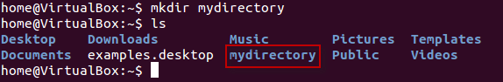](https://www.guru99.com/images/MKdir-1.png)

If you want to create a directory in a different location other than 'Home directory', you could use the following command -

mkdir

For example:

mkdir /tmp/MUSIC

will create a directory 'Music' under '/tmp' directory

[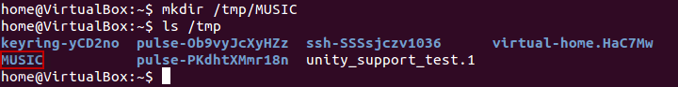](https://www.guru99.com/images/8-2016/linux-5-1.png)

You can also create more than one directory at a time.

[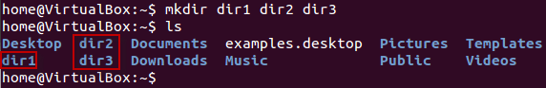](https://www.guru99.com/images/8-2016/linux-5-2.png)

## Removing Directories

To remove a directory, use the command -

rmdir directoryname

Example

rmdir mydirectory

will delete the directory mydirectory

[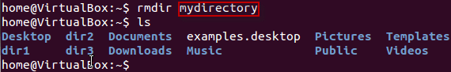](https://www.guru99.com/images/rmdir.png)

**Tip**: Ensure that there is no file / sub-directory under the directory that you want to delete. Delete the files/sub-directory first before deleting the parent directory.

[Must Know Linux/Unix Commands](https://www.guru99.com/images/rmdir1.png)

## Renaming Directory

The 'mv' (move) command (covered earlier) can also be used for renaming directories. Use the below-given format:

mv directoryname newdirectoryname

Let us try it:

[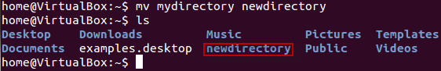](https://www.guru99.com/images/8-2016/linux-5-3.png)

## ****Other Important Commands****

## The 'Man' command

Man stands for manual which is a reference book of a Linux operating system. It is similar to HELP file found in popular software.

To get help on any command that you do not understand, you can type

man

The terminal would open the manual page for that command.

For an example, if we type man man and hit enter; terminal would give us information on man command

[Must Know Linux/Unix Commands](https://www.guru99.com/images/man_man.png)

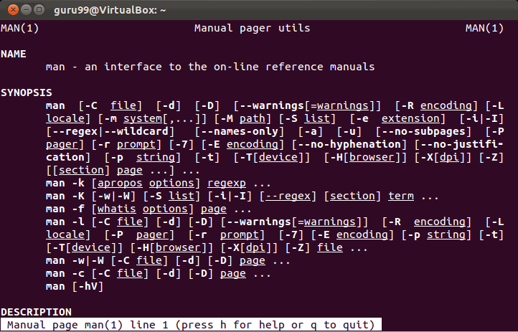

## The History Command

History command shows all the commands that you have used in the past for the current terminal session. This can help you refer to the old commands you have entered and re-used them in your operations again.

[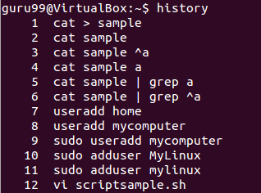](https://www.guru99.com/images/history.png)

## ****The clear command****

This command clears all the clutter on the terminal and gives you a clean window to work on, just like when you launch the terminal.

[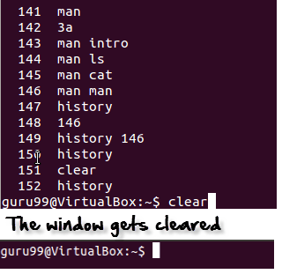](https://www.guru99.com/images/clear.png)

## Pasting commands into the terminal

Many times you would have to type in long commands on the Terminal. Well, it can be annoying at times, and if you want to avoid such a situation then copy, pasting the commands can come to rescue.

For copying, the text from a source, you would use **Ctrl + c,** but for pasting it on the Terminal, you need to use **Ctrl + Shift + p**. You can also try **Shift + Insert or select Edit>Paste on the menu**

NOTE: With Linux upgrades, these shortcuts keep changing. You can set your preferred shortcuts via Terminal> Edit> Keyboard Shortcuts.

## Printing in Unix/Linux

[](https://www.guru99.com/images/print.png)

Let's try out some easy commands which **can print files** in a format you want. What more, your original file does not get affected at all by the formatting that you do. Let us learn about these commands and their use.

<https://youtu.be/cUPpsQ50oyQ>

## 'pr' command

This command helps in formatting the file for printing on the terminal. There are many options available with this command which help in making desired format changes on file. The most used '**pr'** options are listed below.

|  |  |
| --- | --- |
| **Option** | **Function** |
| -x | Divides the data into 'x' columns |
| -h "header" | Assigns "header" value as the report header |
| -t | Does not print the header and top/bottom margins |
| -d | Double spaces the output file |
| -n | Denotes all line with numbers |
| -l page length | Defines the lines (page length) in a page. Default is 56 |
| -o margin | Formats the page by the margin number |

Let us try some of the options and study their effects.

### Dividing data into columns

'**Tools'** is a file (shown below).

[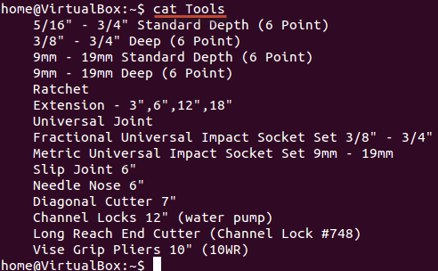](https://www.guru99.com/images/Tools.png)

We want its content to be arranged in three columns. The syntax for the same would be:

pr -x Filename

The '-x' option with the 'pr' command divides the data into x columns.

[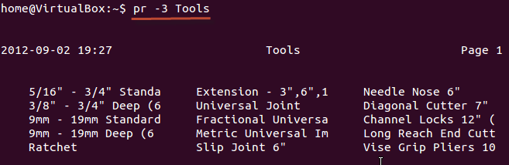](https://www.guru99.com/images/pr_-x.png)

### Assigning a header

The syntax is:

pr -h "Header" Filename

The '-h' options assigns "header" value as the report header.

[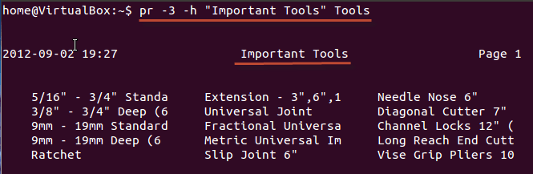](https://www.guru99.com/images/pr_-header.png)

As shown above, we have arranged the file in 3 columns and assigned a header

### Denoting all lines with numbers

The syntax is:

pr -n Filename

This command denotes all the lines in the file with numbers.

[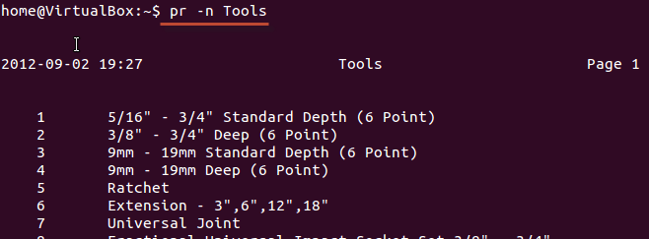](https://www.guru99.com/images/pr_-n.png)

These are some of the 'pr' command options that you can use to modify the file format.

### Printing a file

Once you are **done with the formatting,** and it is time for you to get a **hard copy** of the file, you need to use the following command:

lp Filename

or

lpr Filename

In case you want to print multiple copies of the file, you can use the number modifier.

[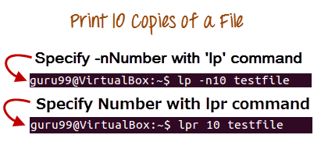](https://www.guru99.com/images/multiple_prints.png)

In case you have multiple printers configured, you can specify a particular printer using the Printer modifier

[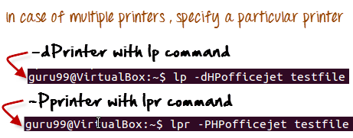](https://www.guru99.com/images/multiple_printers.png)

## Installing Software

In windows, the installation of a program is done by running the setup.exe file. The installation bundle contains the program as well various dependent components required to run the program correctly.

[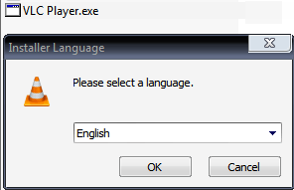](https://www.guru99.com/images/VLCPlayer.png)

In Linux/UNIX, installation files are distributed as packages. But the package contains only the program itself. Any dependent components will have to be installed separately which are usually available as packages themselves.

[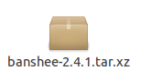](https://www.guru99.com/images/Banshee.png)

You can use the **apt** commands to install or remove a package. Let's update all the installed packages in our system using command -

sudo apt-get update

[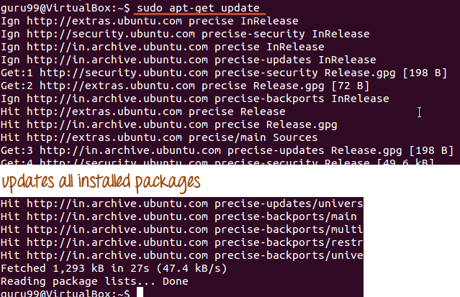](https://www.guru99.com/images/apt.png)

The easy and popular way to install programs on Ubuntu is by using the Software center as most of the software packages are available on it and it is far more secure than the files downloaded from the internet.

[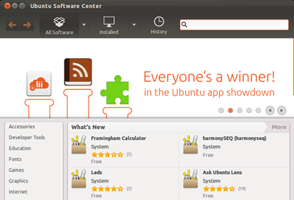](https://www.guru99.com/images/SoftwareCenter.png)

## Sending E-mails

For sending mails through a terminal, you will need to install packages 'mailutils'.

The command syntax is -

sudo apt-get install packagename

Once done, you can then use the following syntax for sending an email.

mail -s 'subject' -c 'cc-address' -b 'bcc-address' 'to-address'

This will look like:

[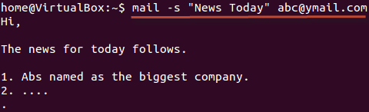](https://www.guru99.com/images/mail.png)

Press Cntrl+D you are finished writing the mail. The mail will be sent to the mentioned address.

**Summary**

* You can format and print a file directly from the terminal. The formatting you do on the files does not affect the file contents
* In Unix/Linux,  software is installed in the form of packages. A package contains the program itself. Any dependent component needs to be downloaded separately.
* You can also send e-mails from terminal using the **'mail' command**

## Cheat Sheet

Below is a Cheat Sheet of Linux commands we have learned in this tutorial

|  |  |
| --- | --- |
| **Command** | **Description** |
| ls | Lists all files and directories in the present working directory |
| ls - R | Lists files in sub-directories as well |
| ls - a | Lists hidden files as well |
| ls - al | Lists files and directories with detailed information like permissions, size, owner, etc. |
| cat > filename | Creates a new file |
| cat filename | Displays the file content |
| cat file1 file2 > file3 | Joins two files (file1, file2) and stores the output in a new file (file3) |
| mv  file "new file path" | Moves the files to the new location |
| mv filename new_file_name | Renames the file to a new filename |
| sudo | Allows regular users to run programs with the security privileges of the superuser or root |
| rm filename | Deletes a file |
| man | Gives help information on a command |
| history | Gives a list of all past commands typed in the current terminal session |
| clear | Clears the terminal |
| mkdir directoryname | Creates a new directory in the present working directory or a at the specified path |
| rmdir | Deletes a directory |
| mv | Renames a directory |
| pr -x | Divides the file into x columns |
| pr -h | Assigns a header to the file |
| pr -n | Denotes the file with Line Numbers |
| lp -nc lpr c | Prints "c" copies of the File |
| lp -d lp -P | Specifies name of the printer |
| apt-get | Command used to install and update packages |
| mail -s 'subject' -c 'cc-address' -b 'bcc-address' 'to-address' | Command to send email |
| mail -s "Subject" to-address < Filename | Command to send email with attachment |

# File Permissions in Linux/Unix with Example

Linux is a clone of UNIX, the **multi-user operating system**which can be accessed by many users simultaneously. Linux can also be used in mainframes and servers without any modifications. But this raises security concerns as an unsolicited or **malign user** can **corrupt, change or remove crucial data**. For effective security, Linux divides authorization into 2 levels.

1. Ownership
2. Permission

In this tutorial, you will learn-

* [Ownership of Linux files](https://www.guru99.com/file-permissions.html#1)
* [Permissions](https://www.guru99.com/file-permissions.html#2)
* [Changing file/directory permissions with 'chmod' command](https://www.guru99.com/file-permissions.html#3)
* [Absolute(Numeric) Mode](https://www.guru99.com/file-permissions.html#4)
* [Symbolic Mode](https://www.guru99.com/file-permissions.html#5)
* [Changing Ownership and Group](https://www.guru99.com/file-permissions.html#6)
* [Summary](https://www.guru99.com/file-permissions.html#7)

The concept of **permissions** and **ownership** is crucial in Linux. Here, we will discuss both of them. Let us start with the **Ownership.**

<https://youtu.be/D-VqgvBMV7g>

## Ownership of Linux files

Every file and directory on your Unix/Linux system is assigned 3 types of owner, given below.

### User

A user is the owner of the file. By default, the person who created a file becomes its owner. Hence, a user is also sometimes called an owner.

### Group

A user- group can contain multiple users. All users belonging to a group will have the same access permissions to the file. Suppose you have a project where a number of people require access to a file. Instead of manually assigning permissions to each user, you could add all users to a group, and assign group permission to file such that only this group members and no one else can read or modify the files.

### Other

Any other user who has access to a file. This person has neither created the file, nor he belongs to a usergroup who could own the file. Practically, it means everybody else. Hence, when you set the permission for others, it is also referred as set permissions for the world.

Now, the big question arises how does **Linux distinguish**between these three user types so that a user 'A' cannot affect a file which contains some other user 'B's' vital information/data. It is like you do not want your colleague, who works on your Linux computer, to view your images. This is where **Permissions** set in, and they define **user behavior**.

Let us understand the **Permission system** on Linux.

## Permissions

Every file and directory in your UNIX/Linux system has following 3 permissions defined for all the 3 owners discussed above.

* **Read:** This permission give you the authority to open and read a file. Read permission on a directory gives you the ability to lists its content.
* **Write:**The write permission gives you the authority to modify the contents of a file. The write permission on a directory gives you the authority to add, remove and rename files stored in the directory. Consider a scenario where you have to write permission on file but do not have write permission on the directory where the file is stored. You will be able to modify the file contents. But you will not be able to rename, move or remove the file from the directory.
* **Execute:**In Windows, an executable program usually has an extension ".exe" and which you can easily run. In Unix/Linux, you cannot run a program unless the execute permission is set. If the execute permission is not set, you might still be able to see/modify the program code(provided read & write permissions are set), but not run it.

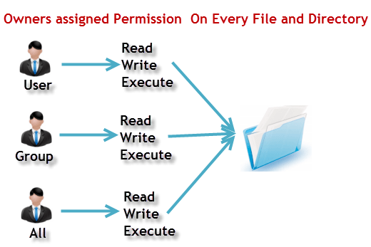

**ls - l** on terminal gives

ls - l

[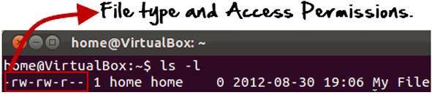](https://www.guru99.com/images/Permis_system.png)

Here, we have highlighted **'-rw-rw-r--'**and this weird looking code is the one that tells us about the permissions given to the owner, user group and the world.

Here, the first '**-**' implies that we have selected a file.p>

[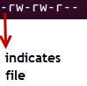](https://www.guru99.com/images/its_a_file.png)

Else, if it were a directory, **d**would have been shown.

[File Permissions in Linux/Unix](https://www.guru99.com/images/Directory.png)

The characters are pretty easy to remember.

**r** = read permission  
**w** = write permission  
**x** = execute permission  
**-** = no permission

Let us look at it this way.

The first part of the code is **'rw-'**. This suggests that the owner 'Home' can:

[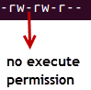](https://www.guru99.com/images/no_execute.png)

* Read the file
* Write or edit the file
* He cannot execute the file since the execute bit is set to '-'.

By design, many Linux distributions like Fedora, CentOS, Ubuntu, etc. will add users to a group of the same group name as the user name. Thus, a user 'tom' is added to a group named 'tom'.

The second part is **'rw-'.** It for the user group 'Home' and group-members can:

* Read the file
* Write or edit the file

The third part is for the world which means any user. It says **'r--'.** This means the user can only:

* Read the file

[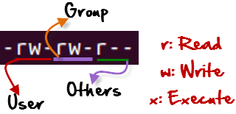](https://www.guru99.com/images/permission(1).png)

## Changing file/directory permissions with 'chmod' command

Say you do not want your colleague to see your personal images. This can be achieved by changing file permissions.

We can use the '**chmod'** command which stands for 'change mode'. Using the command, we can set permissions (read, write, execute) on a file/directory for the owner, group and the world. **Syntax:**

chmod permissions filename

There are 2 ways to use the command -

1. **Absolute mode**
2. **Symbolic mode**

## Absolute(Numeric) Mode

In this mode, file **permissions are not represented as characters but a three-digit octal number**.

The table below gives numbers for all for permissions types.

|  |  |  |
| --- | --- | --- |
| **Number** | **Permission Type** | **Symbol** |
| 0 | No Permission | --- |
| 1 | Execute | --x |
| 2 | Write | -w- |
| 3 | Execute + Write | -wx |
| 4 | Read | r-- |
| 5 | Read + Execute | r-x |
| 6 | Read +Write | rw- |
| 7 | Read + Write +Execute | rwx |

Let's see the chmod command in action.

[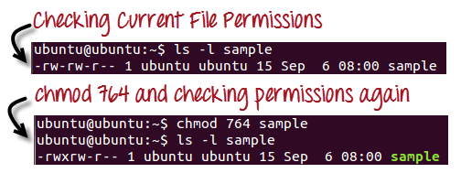](https://www.guru99.com/images/chmod_new(1).png)

In the above-given terminal window, we have changed the permissions of the file 'sample to '764'.

[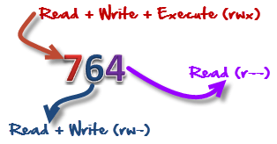](https://www.guru99.com/images/FilePermissions(1).png)

'764' absolute code says the following:

* Owner can read, write and execute
* Usergroup can read and write
* World can only read

**This is shown as '-rwxrw-r-**

This is how you can change the permissions on file by assigning an absolute number.

## Symbolic Mode

In the Absolute mode, you change permissions for all 3 owners. In the symbolic mode, you can modify permissions of a specific owner. It makes use of mathematical symbols to modify the file permissions.

|  |  |
| --- | --- |
| **Operator** | **Description** |
| **+** | Adds a permission to a file or directory |
| **-** | Removes the permission |
| **=** | Sets the permission and overrides the permissions set earlier. |

The various owners are represented as -

|  |  |
| --- | --- |
| **User Denotations** | |
| u | user/owner |
| g | group |
| o | other |
| a | all |

We will not be using permissions in numbers like 755 but characters like rwx. Let's look into an example

[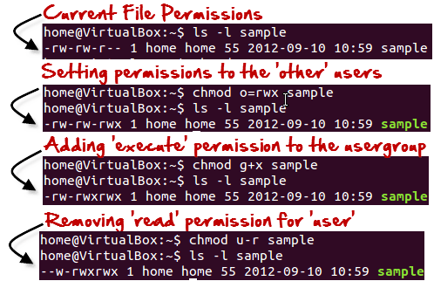](https://www.guru99.com/images/Symbolic_Mode(1).png)

## Changing Ownership and Group

For changing the ownership of a file/directory, you can use the following command:

chown user

In case you want to change the user as well as group for a file or directory use the command

chown user:group filename

Let's see this in action

[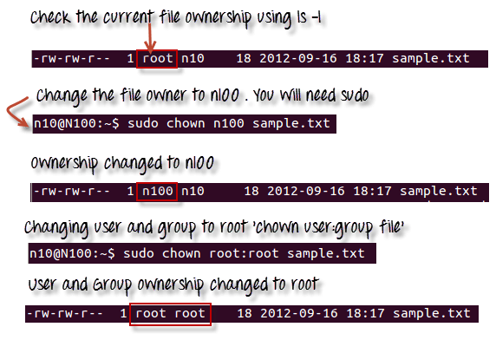](https://www.guru99.com/images/chown_comm(1).png)

In case you want to change group-owner only, use the command

chgrp group_name filename

'**chgrp'** stands for change group.

[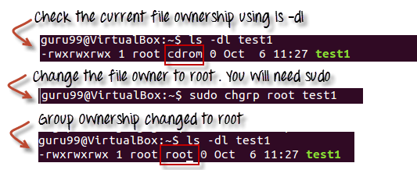](https://www.guru99.com/images/chgrp.png)

### Tip

* The file /etc/group contains all the groups defined in the system
* You can use the command "groups" to find all the groups you are a member of

[File Permissions in Linux/Unix](https://www.guru99.com/images/groups.png)

* You can use the command newgrp to work as a member a group other than your default group

[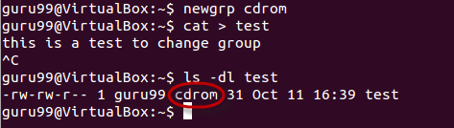](https://www.guru99.com/images/newgrp.png)

* You cannot have 2 groups owning the same file.
* You do not have nested groups in Linux. One group cannot be sub-group of other
* x- eXecuting a directory means Being allowed to "enter" a dir and gain possible access to sub-dirs
* There are other permissions that you can set on Files and Directories which will be covered in a later advanced tutorial

## Summary:

* Linux being a multi-user system uses permissions and ownership for security.
* There are three user types on a Linux system viz. User, Group and Other
* Linux divides the file permissions into read, write and execute denoted by r,w, and x
* The permissions on a file can be changed by 'chmod' command which can be further divided into Absolute and Symbolic mode
* The 'chown' command can change the ownership of a file/directory. Use the following commands: chown user file or chown user:group file
* The 'chgrp' command can change the group ownership **chrgrp group filename**
* What does x - eXecuting a directory mean? A: Being allowed to "enter" a dir and gain possible access to sub-dirs.

# Input Output Redirection in Linux/Unix Examples

### What is Redirection?

Redirection is a feature in Linux such that when executing a command, you can change the standard input/output devices. The basic workflow of any Linux command is that it takes an input and give an output.

* The standard input (stdin) device is the keyboard.
* The standard output (stdout) device is the screen.

With redirection, the above standard input/output can be changed.

In this tutorial, we will learn-

* [Output Redirection](https://www.guru99.com/linux-redirection.html#1)
* [Input redirection](https://www.guru99.com/linux-redirection.html#2)
* [File Descriptors (FD)](https://www.guru99.com/linux-redirection.html#3)
* [Error Redirection](https://www.guru99.com/linux-redirection.html#4)
* [Why Error Redirection?](https://www.guru99.com/linux-redirection.html#5)
* [Examples](https://www.guru99.com/linux-redirection.html#6)

<https://youtu.be/Bzd7XfApxLI>

## Output Redirection

The **'>**' symbol is used for output (STDOUT) redirection.

[Redirection in Linux/Unix - Demystified!](https://www.guru99.com/images/OutputRedirection.png)

Example:

ls -al > listings

Here the output of command ls -al is re-directed to file "listings" instead of your screen.

**[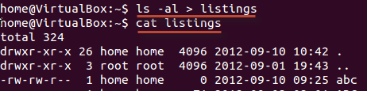](https://www.guru99.com/images/al_-l.png)**

**Note**: Use the correct file name while redirecting command output to a file. If there is an existing file with the same name, the redirected command will delete the contents of that file and then it may be overwritten."

If you do not want a file to be overwritten but want to add more content to an existing file, then you should use **'>>**' operator.

[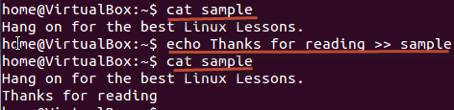](https://www.guru99.com/images/append.png)

You can redirect standard output, to not just files, but also devices!

$ cat music.mp3 > /dev/audio

The cat command reads the file music.mp3 and sends the output to /dev/audio which is the audio device. If the sound configurations in your PC are correct, this command will play the file music.mp3

## Input redirection

The **'<**' symbol is used for input(STDIN) redirection

[Redirection in Linux/Unix - Demystified!](https://www.guru99.com/images/InputRedirection.png)

Example: The mail program in Linux can help you send emails from the Terminal.

You can type the contents of the email using the standard device keyboard. But if you want to attach a File to email you can use the input re-direction operator in the following format.

Mail -s "Subject" to-address < Filename

[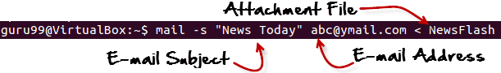](https://www.guru99.com/images/Email.png)

This would attach the file with the email, and it would be sent to the recipient.

The above examples were simple. Let's look at some advance re-direction techniques which make use of File Descriptors.

## File Descriptors (FD)

In Linux/Unix, everything is a file. Regular file, Directories, and even Devices are files. Every File has an associated number called File Descriptor (FD).

Your screen also has a File Descriptor. When a program is executed the output is sent to File Descriptor of the screen, and you see program output on your monitor. If the output is sent to File Descriptor of the printer, the program output would have been printed.

## Error Redirection

Whenever you execute a program/command at the terminal, 3 files are always open, viz., standard input, standard output, standard error**.**

[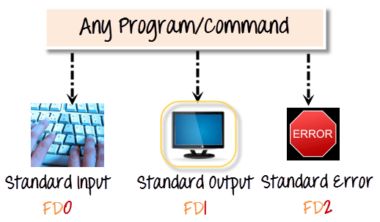](https://www.guru99.com/images/Streams.png)

These files are always present whenever a program is run. As explained before a file descriptor, is associated with each of these files.

|  |  |
| --- | --- |
| **File** | **File Descriptor** |
| **Standard Input STDIN** | **0** |
| **Standard Output STDOUT** | **1** |
| **Standard Error STDERR** | **2** |

By default, error stream is displayed on the screen. Error redirection is routing the errors to a file other than the screen.

## Why Error Redirection?

Error re-direction is one of the very popular features of Unix/Linux.

Frequent UNIX users will reckon that many commands give you massive amounts of errors.

* For instance, while searching for files, one typically gets permission denied errors. These errors usually do not help the person searching for a particular file.
* While executing shell scripts, you often do NOT want error messages cluttering up the normal program output.

The solution is to re-direct the error messages to a file.

**Example 1**

$ myprogram 2>errorsfile

[Redirection in Linux/Unix - Demystified!](https://www.guru99.com/images/myprogram.jpg)

Above we are executing a program names myprogram.

The file descriptor for standard error is 2.

Using "2>" we re-direct the error output to a file named "errorfile"

Thus, program output is not cluttered with errors.

**Example 2**

Here is another example which uses find statement -

find . -name 'my*' 2>error.log

Using the "find" command, we are searching the "." current directory for a file with "name" starting with "my"

[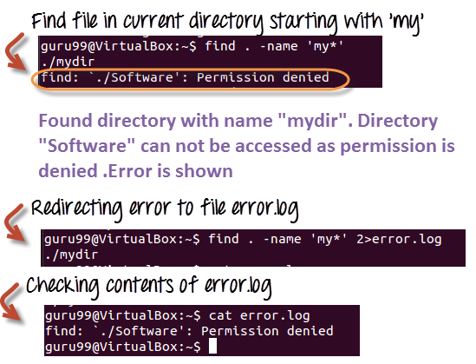](https://www.guru99.com/images/standard_error.png)

**Example 3** Let's see a more complex example,

Server Administrators frequently, list directories and store both error and standard output into a file, which can be processed later. Here is the command.

ls Documents ABC> dirlist 2>&1

Here,

* which writes the output from one file to the input of another file. 2>&1 means that STDERR redirects to the target of STDOUT (which is the file dirlist)
* We are redirecting error output to standard output which in turn is being re-directed to file dirlist. Hence, both the output is written to file dirlist

[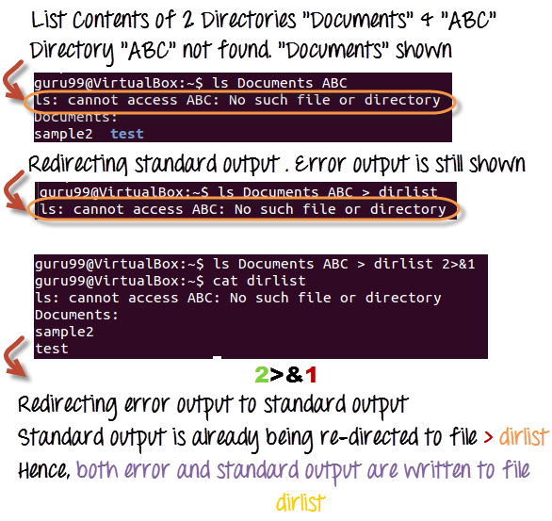](https://www.guru99.com/images/Redirection(1).png)

## Summary

* Each file in Linux has a corresponding File Descriptor associated with it
* The keyboard is the standard input device while your screen is the standard output device
* ">" is the output redirection operator. ">>" appends output to an existing file
* "<" is the input redirection operator
* ">&"re-directs output of one file to another.
* You can re-direct error using its corresponding File Descriptor 2.

# Pipe, Grep and Sort Command in Linux/Unix with Examples

In this tutorial, we will learn-

* [What is a Pipe in Linux?](https://www.guru99.com/linux-pipe-grep.html#1)
* ['pg' and 'more' commands](https://www.guru99.com/linux-pipe-grep.html#2)
* [The 'grep' command](https://www.guru99.com/linux-pipe-grep.html#3)
* [The 'sort' command](https://www.guru99.com/linux-pipe-grep.html#4)
* [What is a Filter?](https://www.guru99.com/linux-pipe-grep.html#5)

## What is a Pipe in Linux?

The Pipe is a command in Linux that lets you use two or more commands such that output of one command serves as input to the next. In short, the output of each process directly as input to the next one like a pipeline. The symbol '|' denotes a pipe.

Pipes help you mash-up two or more commands at the same time and run them consecutively. You can use powerful commands which can perform complex tasks in a jiffy.

Let us understand this with an example.

When you use 'cat' command to view a file which spans multiple pages, the prompt quickly jumps to the last page of the file, and you do not see the content in the middle.

To avoid this, you can pipe the output of the 'cat' command to 'less' which will show you only one scroll length of content at a time.

cat filename | less

An illustration would make it clear.

[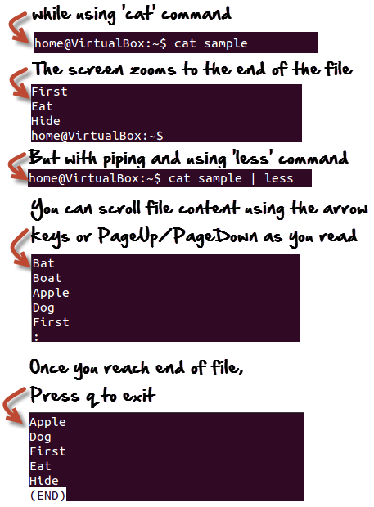](https://www.guru99.com/images/Piping.png)

<https://youtu.be/VgbnndezHbw>

## 'pg' and 'more' commands

Instead of 'less', you can also use.

cat Filename | pg

or

cat Filename | more

And, you can view the file in digestible bits and scroll down by simply hitting the enter key.

[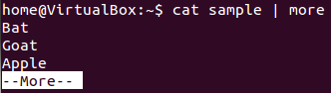](https://www.guru99.com/images/more.png)

## The 'grep' command

Suppose you want to search a particular information the postal code from a text file.

You may manually skim the content yourself to trace the information. A better option is to use the grep command. It will scan the document for the desired information and present the result in a format you want.

**Syntax:**

grep search_string

Let's see it in action -

[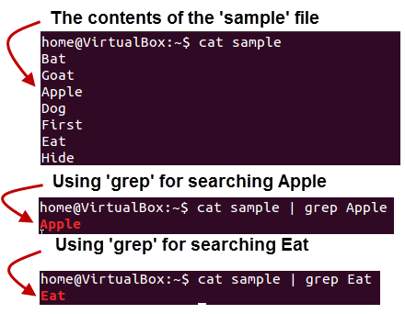](https://www.guru99.com/images/Grep_command.png)

Here, **grep** command has searched the file 'sample', for the string 'Apple' and 'Eat'.

Following options can be used with this command.

|  |  |
| --- | --- |
| **Option** | **Function** |
| -v | Shows all the lines that do not match the searched string |
| -c | Displays only the count of matching lines |
| -n | Shows the matching line and its number |
| -i | Match both (upper and lower) case |
| -l | Shows just the name of the file with the string |

Let us try the first option **'-i'**on the same file use above -

Using the  'i' option grep has filtered the string 'a' (case-insensitive) from the all the lines.

[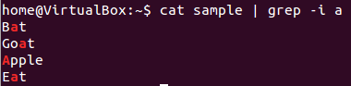](https://www.guru99.com/images/grep_-i.png)

## The 'sort' command

This command helps in **sorting out the contents of a file alphabetically.**

The syntax for this command is:

sort Filename

Consider the contents of a file.

[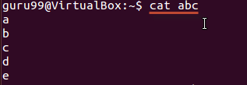](https://www.guru99.com/images/cat_abc.png)

Using the sort command

[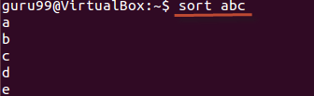](https://www.guru99.com/images/sort_abc.png)

There are **extensions** to this command as well, and they are listed below.

|  |  |
| --- | --- |
| **Option** | **Function** |
| -r | Reverses  sorting |
| -n | Sorts numerically |
| -f | Case insensitive sorting |

The example below shows reverse sorting of the contents in file 'abc'.

[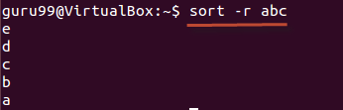](https://www.guru99.com/images/sort_-r_abc(1).png)

## What is a Filter?

Linux has a lot of filter commands like awk, grep, sed, spell, and wc. A filter takes input from one command, does some processing, and gives output.

When you pipe two commands, the "filtered " output of the first command is given to the next.

[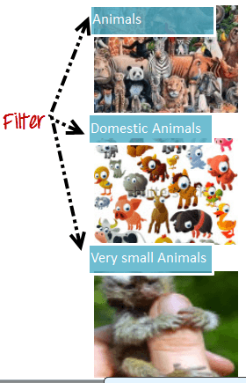](https://www.guru99.com/images/Filter(1).png)

Let's understand this with the help of an example.

We have the following file 'sample'

[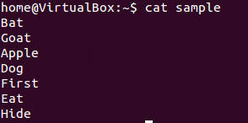](https://www.guru99.com/images/cat_sample.png)

**We want to highlight** only the lines that do not contain the character 'a', but the result should be in reverse order.

For this, the following syntax can be used.

cat sample | grep -v a | sort - r

Let us look at the result.

[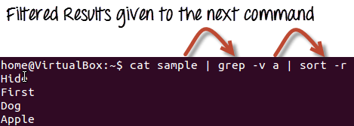](https://www.guru99.com/images/empirical_usage.png)

### Summary:

* Pipes '|' send the output of one command as input of another command.
* The Filter takes input from one command, does some processing, and gives output.
* The grep command can be used to find strings and values in a text document
* Piping through grep has to be one of the most common uses
* 'sort' command sorts out the content of a file alphabetically
* less ,pg and more commands are used for dividing a long file into readable bits

# Linux Regular Expression Tutorial: Grep Regex Example

## What are Regular Expressions?

Regular expressions are special characters which help search data, matching complex patterns. Regular expressions are shortened as 'regexp' or 'regex'.

## Types of Regular expressions

For ease of understanding let us learn the different types of Regex one by one.

* [Basic Regular expressions](https://www.guru99.com/linux-regular-expressions.html#1)
* [Interval Regular expressions](https://www.guru99.com/linux-regular-expressions.html#2)
* [Extended regular expressions](https://www.guru99.com/linux-regular-expressions.html#3)
* [Summary](https://www.guru99.com/linux-regular-expressions.html#4)

<https://youtu.be/mpyCeSvGh-M>

## Basic Regular expressions

Some of the commonly used commands with Regular expressions are tr, sed, vi and grep. Listed below are some of the basic Regex.

|  |  |
| --- | --- |
| **Symbol** | **Descriptions** |
| . | replaces any character |
| ^ | matches start of string |
| $ | matches end of string |
| * | matches up zero or more times the preceding character |
| \ | Represent special characters |
| () | Groups regular expressions |
| ? | Matches up exactly one character |

Let's see an example.

Execute cat sample to see contents of an existing file

[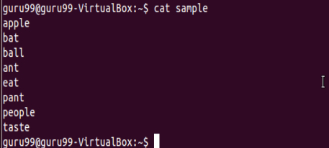](https://www.guru99.com/images/regex1.png)

Search for content containing letter 'a'.

[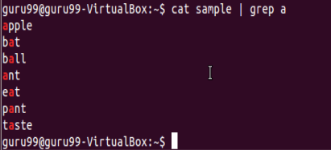](https://www.guru99.com/images/regex2.png)

'**^**' matches the start of a string. Let's search for content that STARTS with a

[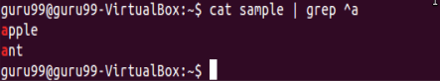](https://www.guru99.com/images/regex3.png)

Only lines that start with character are filtered. Lines which do not contain the character 'a' at the start are ignored.

Let's look into another example -

[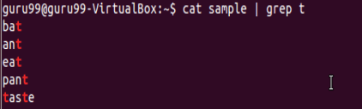](https://www.guru99.com/images/regex4.png)

Select only those lines that end with t using**$**

[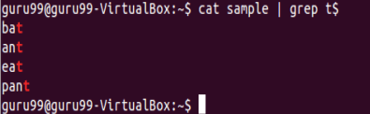](https://www.guru99.com/images/regex5.png)

## Interval Regular expressions

These expressions tell us about the number of occurrences of a character in a string. They are

|  |  |
| --- | --- |
| **Expression** | **Description** |
| {n} | Matches the preceding character appearing 'n' times exactly |
| {n,m} | Matches the preceding character appearing 'n' times but not more than m |
| {n, } | Matches the preceding character only when it appears 'n' times or more |

Example:

Filter out all lines that contain character 'p'

[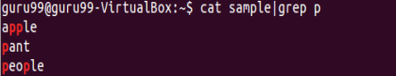](https://www.guru99.com/images/regex6.png)

We want to check that the character 'p' appears exactly 2 times in a string one after the other. For this the syntax would be:

cat sample | grep -E p\{2}

[Linux - Regular Expressions](https://www.guru99.com/images/regex7.png)

Note: You need to add -E with these regular expressions.

## Extended regular expressions

These regular expressions contain combinations of more than one expression. Some of them are:

|  |  |
| --- | --- |
| **Expression** | **Description** |
| \+ | Matches one or more occurrence of the previous character |
| \? | Matches zero or one occurrence of the previous character |

Example:

Searching for all characters 't'

[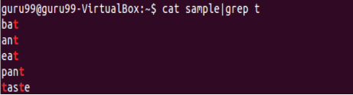](https://www.guru99.com/images/regex8.png)

Suppose we want to filter out lines where character 'a' precedes character 't'

We can use command like

cat sample|grep "a\+t"

[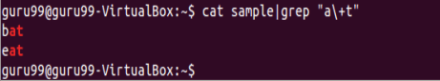](https://www.guru99.com/images/regex9.png)

## Brace expansion

The syntax for brace expansion is either a sequence or a comma separated list of items inside curly braces "{}". The starting and ending items in a sequence are separated by two periods "..".

Some examples:

[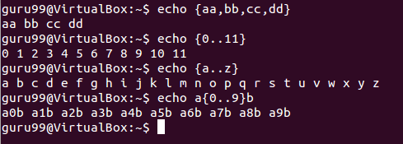](https://www.guru99.com/images/brace_expansion.png)

In the above examples, the echo command creates strings using the brace expansion.

## Summary:

* Regular expressions are a set of characters used to check patterns in strings
* They are also called 'regexp' and 'regex'
* It is important to learn regular expressions for writing scripts
* Some basic regular expressions are:

|  |  |
| --- | --- |
| **Symbol** | **Descriptions** |
| . | replaces any character |
| ^ | matches start of string |
| $ | matches end of string |

* Some extended regular expressions are:

|  |  |
| --- | --- |
| **Expression** | **Description** |
| \+ | Matches one or more occurrence of the previous character |
| \? | Matches zero or one occurrence of the previous character |

* Some interval regular expressions are:

|  |  |
| --- | --- |
| **Expression** | **Description** |
| {n} | Matches the preceding character appearing 'n' times exactly |
| {n,m} | Matches the preceding character appearing 'n' times but not more than m |
| {n, } | Matches the preceding character only when it appears 'n' times or more |

* The brace expansion is used to generate strings. It helps in creating multiple strings out of one.

# List of Environment Variables in Linux/Unix

In this tutorial, you will learn-

* [What is a Computing Environment?](https://www.guru99.com/linux-environment-variables.html#1)
* [What is a Variable?](https://www.guru99.com/linux-environment-variables.html#2)
* [What are Environment variables?](https://www.guru99.com/linux-environment-variables.html#3)
* [Accessing Variable values](https://www.guru99.com/linux-environment-variables.html#4)
* [Set New Environment Variables](https://www.guru99.com/linux-environment-variables.html#5)

## What is a Computing Environment?

The Computing environment is the Platform(Platform = Operating System+ Processor) where a user can run programs.

## What is a Variable?

In computer science, a **variable is a location for storing a value** **which can be a** **filename**, **text**, **number** or any other **data**. It is usually referred to with its Symbolic name which is given to it while creation. The value thus stored can be displayed, deleted, edited and re-saved.

Variables play an important role in computer programming because they enable programmers to write flexible programs. As they are related to the Operating system that we work on, it is important to know some of them and how we can influence them.

## What are Environment variables?

Environment variables are dynamic values which affect the processes or programs on a computer. They exist in every operating system, but types may vary. Environment variables can be created, edited, saved, and deleted and give information about the system behavior.

Environment variables can change the way a software/programs behave.

<https://youtu.be/pjh9rU9h22Q>

E.g. $LANG environment variable stores the value of the language that the user understands. This value is read by an application such that a Chinese user is shown a Mandarin interface while an American user is shown an English interface.

Let's study some common environment variables -

|  |  |
| --- | --- |
| **Variable** | **Description** |
| **PATH** | This variable contains a colon (:)-separated list of directories in which your system looks for executable files. [Linux - Environment Variables](https://www.guru99.com/images/echoPath.png) When you enter a command on terminal, the shell looks for the command in different directories mentioned in the $PATH variable. If the command is found, it executes. Otherwise, it returns with an error 'command not found'. |
| **USER** | The username |
| **HOME** | Default path to the user's home directory |
| **EDITOR** | Path to the program which edits the content of files |
| **UID** | User's unique ID |
| **TERM** | Default terminal emulator |
| **SHELL** | Shell being used by the user |

## Accessing Variable values

In order to determine value of a variable, use the command

echo $VARIABLE

Variables are- Case Sensitive. Make sure that you type the variable name in the right letter case otherwise you may not get the desired results.

[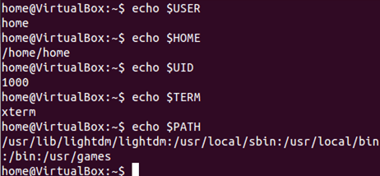](https://www.guru99.com/images/echo.png)

The '**env'** command displays **all the environment variables.**

[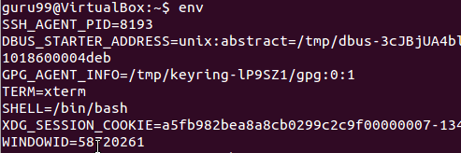](https://www.guru99.com/images/env.png)

## Set New Environment Variables

You can create your own user defined variable, with syntax

VARIABLE_NAME= variable_value

Again, bear in mind **that variables are case-sensitive** and usually they are created in upper case.

[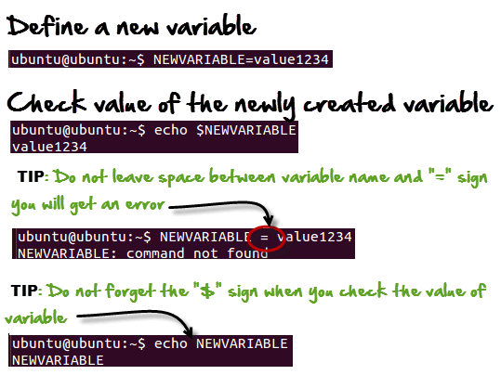](https://www.guru99.com/images/New_variable.png)

## Deleting Variables

The following syntax can be used to remove a Variable from the system.

unset variablename

[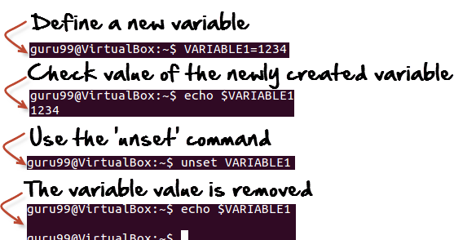](https://www.guru99.com/images/unset.png)

This **would remove the Variable** and its value permanently.

### Summary:

* Environment variables govern the behavior of programs in your Operating System.

|  |  |
| --- | --- |
| **Command** | **Description** |
| echo $VARIABLE | To display value of a variable |
| env | Displays all environment variables |
| VARIABLE_NAME= variable_value | Create a new variable |
| unset | Remove a variable |
| export Variable=value | To set value of an environment variable |

# Linux/Unix SSH, Ping, FTP, Telnet Communication Commands

While working on a Linux operating system, you may need to **communicate with other devices**. For this, there are some basic utilities that you can make use of.

These utilities can help you communicate with:

* networks,
* other Linux systems
* and remote users

So, let us learn them one by one.

* [SSH](https://www.guru99.com/communication-in-linux.html#1)
* [Ping](https://www.guru99.com/communication-in-linux.html#2)
* [FTP](https://www.guru99.com/communication-in-linux.html#3)
* [Telnet](https://www.guru99.com/communication-in-linux.html#4)

<https://youtu.be/9mj8o5BQN_Y>

## SSH

SSH which stands for Secure Shell, It is used to connect to a remote computer securely. Compare to Telnet, SSH is secure wherein the client /server connection is authenticated using a digital certificate and passwords are encrypted. Hence it's widely used by system administrators to control remote Linux servers.

The syntax to log into a remote Linux machine using SSH is

SSH username@ip-address or hostname

[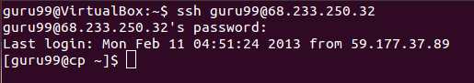](https://www.guru99.com/images/11-Feb-13_3-24-15_PM.png)

Once you are logged in, you can execute any commands that you do in your terminal

**Example:**

ls

[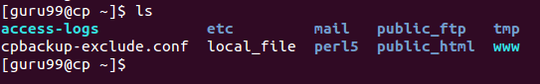](https://www.guru99.com/images/11-Feb-13_3-24-50_PM.png)

**Example:**

pwd

[Linux/Unix SSH, Ping, FTP, Telnet Communication Commands](https://www.guru99.com/images/11-Feb-13_3-25-12_PM.png)

## Ping

This utility is commonly used to check whether your **connection to the server** is healthy or not.This command is also used in -

* Analyzing network and host connections
* Tracking network performance and managing it
* Testing hardware and software issues

[](https://www.guru99.com/images/communication(1).png)

Command Syntax:-

ping hostname="" or=""

Example :

ping 172.16.170.1

**[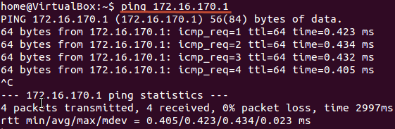](https://www.guru99.com/images/ping.png)**

ping google.com

[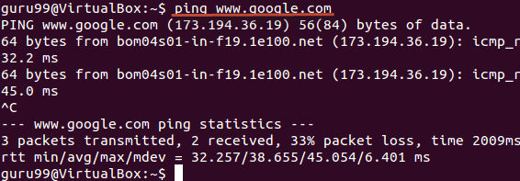](https://www.guru99.com/images/ping_hostname.png)

Here, A system has sent 64 bytes data packets to the IP Address (172.16.170.1) or the Hostname(www.google.com). If even one of data packets does not return or is lost, it would suggest an error in the connection. Usually, internet connectivity is checked using this method.

You may Press **Ctrl + c** to **exit** from the ping loop.

## FTP

FTP **is file transfer protocol**. It's the **most preferred protocol for** **data transfer** amongst computers.

You can use FTP to -

* Logging in and establishing a connection with a remote host
* Upload and download files
* Navigating through directories
* Browsing contents of the directories

[](https://www.guru99.com/images/ftp(1).png)

The syntax to establish an FTP connection to a remote host is -

ftp hostname="" or=""

Once you enter this command, it will ask you for **authentication** via username and password.

[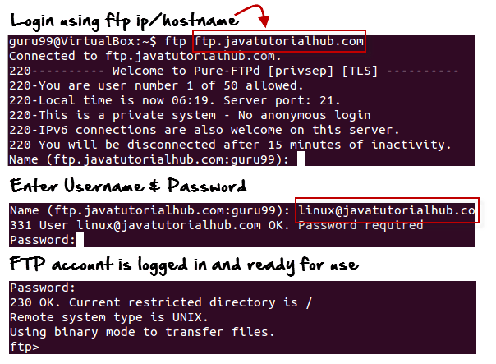](https://www.guru99.com/images/FTP_login.png)

Once a connection is established, and you are logged in, you may use the following commands to perform different actions.

|  |  |
| --- | --- |
| **Command** | **Function** |
| dir | Display files in the current directory of a remote computer |
| cd "dirname" | change directory to "dirname" on a remote computer |
| put file | upload 'file' from local to remote computer |
| get file | Download 'file' from remote to local computer |
| quit | Logout |

Let us run some of the important commands.

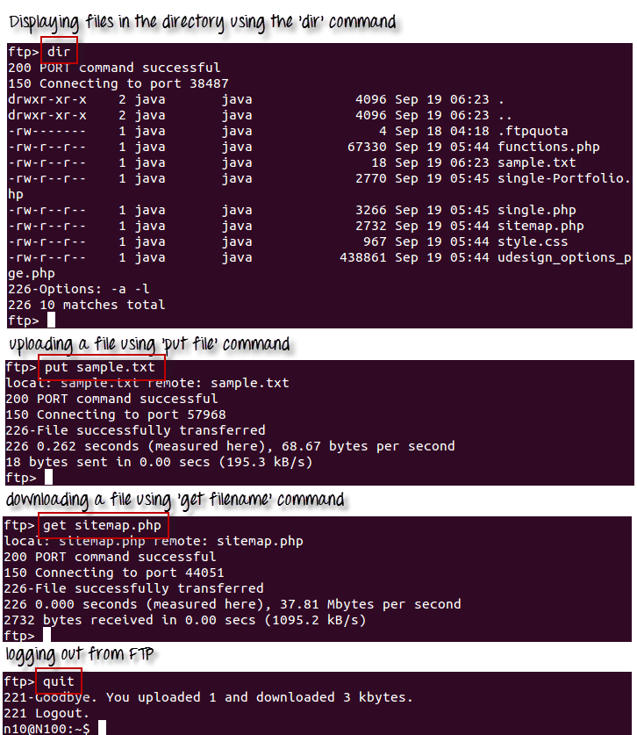

## Telnet

Telnet helps to -

* connect to a remote Linux computer
* run programs remotely and conduct administration

[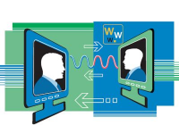](https://www.guru99.com/images/telnet(1).png)

This utility is similar to the Remote Desktop feature found in Windows Machine.

The syntax for this utility is:

telnet hostname="" or=""

Example:

telnet localhost

For demonstration purpose, we will connect to your computer (localhost). The utility will ask your username and password.

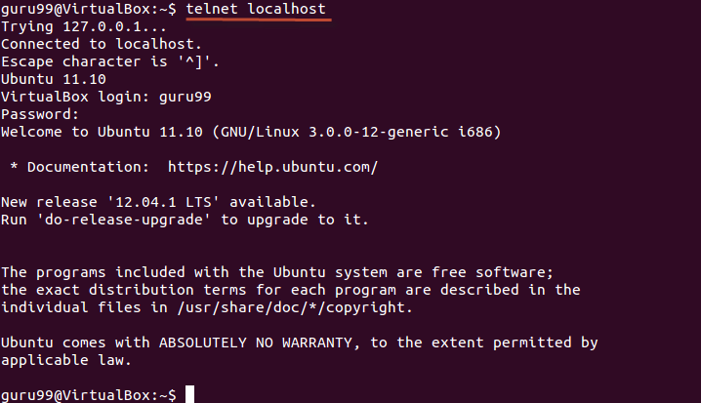

Once authenticated, you can execute commands just like you have done so far, using the Terminal. The only difference is, if you are connected to a remote host, the commands will be executed on the remote machine, and not your local machine.

You may exit the telnet connection by entering the command 'logout'

## Summary:

* Communication between Linux/UNIX and other different computers, networks and remote users is possible.
* The ping command checks whether the connection with a hostname or IP-address is working or not. Run 'ping IP address or Hostname' on the terminal
* FTP is preferred protocol for sending and receiving large files. You can establish an FTP connection to a remote host and then use commands for uploading, downloading files, checking file and browsing them
* Telnet utility helps you to connect to a remote Linux computer and work on it

# Linux/Unix Process Management: ps, kill, top, df, free, nice Commands

In this tutorial, you will learn-

* [What is a Process?](https://www.guru99.com/managing-processes-in-linux.html#1)
* [Running a Foreground Process](https://www.guru99.com/managing-processes-in-linux.html#2)
* [Running a Background process](https://www.guru99.com/managing-processes-in-linux.html#3)
* [Fg](https://www.guru99.com/managing-processes-in-linux.html#4)
* [Top](https://www.guru99.com/managing-processes-in-linux.html#5)
* [PS](https://www.guru99.com/managing-processes-in-linux.html#6)
* [Kill](https://www.guru99.com/managing-processes-in-linux.html#7)
* [NICE](https://www.guru99.com/managing-processes-in-linux.html#8)
* [DF](https://www.guru99.com/managing-processes-in-linux.html#9)
* [Free](https://www.guru99.com/managing-processes-in-linux.html#10)

## What is a Process?

An instance of a program is called a Process. In simple terms, any command that you give to your Linux machine starts a new process.

[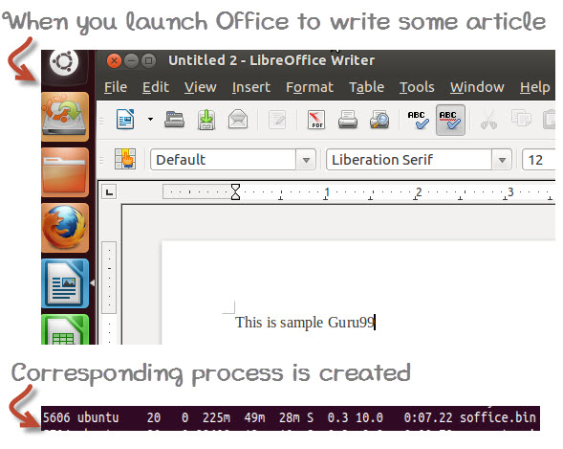](https://www.guru99.com/images/whatisprocessid.jpg)

Having multiple processes for the same program is possible.

Types of Processes:

* Foreground Processes: They run on the screen and need input from the user. For example Office Programs
* Background Processes: They run in the background and usually do not need user input. For example Antivirus.

<https://youtu.be/P8GrPOpD8Sk>

## Running a Foreground Process

To start a foreground process, you can either run it from the dashboard, or you can run it from the terminal.

When using the Terminal, you will have to wait, until the foreground process runs.

[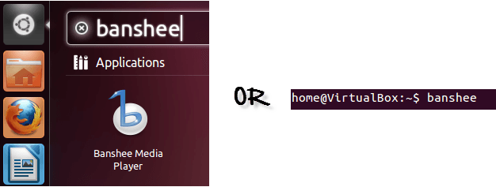](https://www.guru99.com/images/foreground.png)

## Running a Background process

If you start a foreground program/process from the terminal, then you cannot work on the terminal, till the program is up and running.

Particular, data-intensive tasks take lots of processing power and may even take hours to complete. You do not want your terminal to be held up for such a long time.

To avoid such a situation, you can run the program and send it to the background so that terminal remains available to you. Let's learn how to do this -

[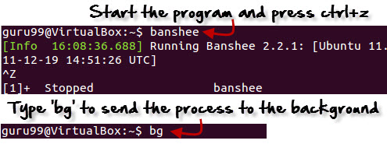](https://www.guru99.com/images/bg.jpg)

## Fg

You can use the command "fg" to continue a program which was stopped and bring it to the foreground.

The simple syntax for this utility is:

fg jobname

Example

1. Launch 'banshee' music player
2. Stop it with the 'ctrl +z' command
3. Continue it with the 'fg' utility.

[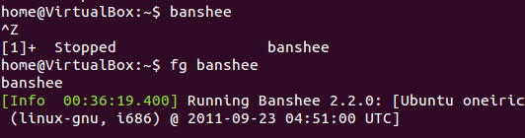](https://www.guru99.com/images/fg.png)

Let's look at other important commands to manage processes -

## Top

This utility tells the user about all the running processes on the Linux machine.

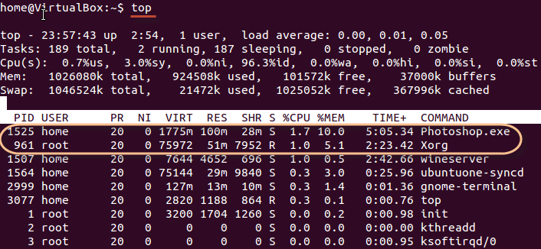

Press 'q' on the keyboard to move out of the process display.

The terminology follows:

| **Field** | **Description** | **Example 1** | **Example 2** |
| --- | --- | --- | --- |
| PID | The process ID of each task | 1525 | 961 |
| User | The username of task owner | Home | Root |
| PR | Priority Can be 20(highest) or -20(lowest) | 20 | 20 |
| NI | The nice value of a task | 0 | 0 |
| VIRT | Virtual memory used (kb) | 1775 | 75972 |
| RES | Physical memory used (kb) | 100 | 51 |
| SHR | Shared memory used (kb) | 28 | 7952 |
| S | Status  There are five types:            'D' = uninterruptible sleep            'R' = running            'S' = sleeping            'T' = traced or stopped            'Z' = zombie | S | R |
| %CPU | % of CPU time | 1.7 | 1.0 |
| %MEM | Physical memory used | 10 | 5.1 |
| TIME+ | Total CPU time | 5:05.34 | 2:23.42 |
| Command | Command name | Photoshop.exe | Xorg |

## PS

This command stands for 'Process Status'. It is similar to the "Task Manager" that pop-ups in a Windows Machine when we use Cntrl+Alt+Del. This command is similar to 'top' command but the information displayed is different.

To check all the processes running under a user, use the command -

ps ux

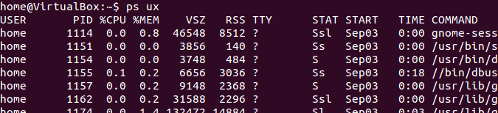

You can also check the process status of a single process, use the syntax -

ps PID

[Managing Processes in Linux/Unix: top, ps, kill, df, free, nice](https://www.guru99.com/images/ps_pid.jpg)

## Kill

This command **terminates running processes** on a Linux machine.

To use these utilities you need to know the PID (process id) of the process you want to kill

Syntax -

kill PID

To find the PID of a process simply type

pidof Process name

Let us try it with an example.

[Managing Processes in Linux/Unix: top, ps, kill, df, free, nice](https://www.guru99.com/images/kill.png)

## NICE

Linux can run a lot of processes at a time, which can slow down the speed of some high priority processes and result in poor performance.

To avoid this, you can tell your machine to prioritize processes as per your requirements.

This priority is called Niceness in Linux, and it has a value between -20 to 19. The lower the Niceness index, the higher would be a priority given to that task.

The default value of all the processes is 0.

To start a process with a niceness value other than the default value use the following syntax

nice -n 'Nice value' process name

[Managing Processes in Linux/Unix: top, ps, kill, df, free, nice](https://www.guru99.com/images/changing_niceness.png)

If there is some process already running on the system, then you can 'Renice' its value using syntax.

renice 'nice value' -p 'PID'

To change Niceness, you can use the 'top' command to determine the PID (process id) and its Nice value. Later use the renice command to change the value.

Let us understand this by an example.

[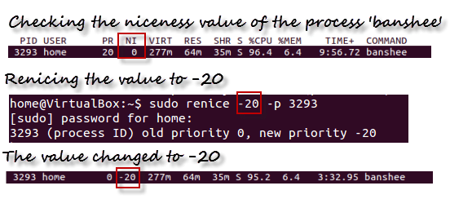](https://www.guru99.com/images/renicing.png)

## DF

This utility reports the free disk space(Hard Disk) on all the file systems.

[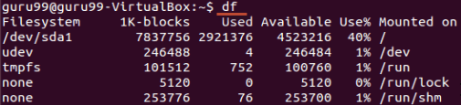](https://www.guru99.com/images/df.png)

If you want the above information in a readable format, then use the command

'df -h'

[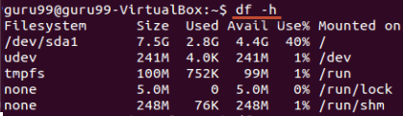](https://www.guru99.com/images/df-h.png)

## Free

This command shows the free and used memory (RAM) on the Linux system.

[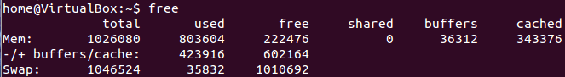](https://www.guru99.com/images/free.png)

You can use the arguments

free -m to display output in MB

free -g to display output in GB

## Summary:

* Any running program or a command given to a Linux system is called a process
* A process could run in foreground or background
* The priority index of a process is called Nice in Linux. Its default value is 0, and it can vary between 20 to -19
* The lower the Niceness index, the higher would be priority given to that task

| **Command** | **Description** |
| --- | --- |
| **bg** | To send a process to the background |
| **fg** | To run a stopped process in the foreground |
| **top** | Details on all Active Processes |
| **ps** | Give the status of processes running for a user |
| **ps PID** | Gives the status of a particular process |
| **pidof** | Gives the Process ID (PID) of a process |
| **kill PID** | Kills a process |
| **nice** | Starts a process with a given priority |
| **renice** | Changes priority of an already running process |
| **df** | Gives free hard disk space on your system |
| **free** | Gives free RAM on your system |

# VI Text Editor with Commands: Linux/Unix Tutorial

## What is the VI editor?

The VI editor is the most popular and classic text editor in the Linux family. Below, are some reasons which make it a widely used editor –

1) It is available in almost all Linux Distributions

2) It works the same across different platforms and Distributions

3) It is user-friendly. Hence, millions of Linux users love it and use it for their editing needs

Nowadays, there are advanced versions of the vi editor available, and the most popular one is **VIM**which is **V**i **Im**proved. Some of the other ones are Elvis, Nvi, Nano, and Vile. It is wise to learn vi because it is feature-rich and offers endless possibilities to edit a file.

To work on VI editor, you need to understand **its operation modes**. They can be divided into two main parts.

In this tutorial, you will learn more about-

* [Command mode](https://www.guru99.com/the-vi-editor.html#2)
* [Insert mode](https://www.guru99.com/the-vi-editor.html#3)
* [Starting the vi editor](https://www.guru99.com/the-vi-editor.html#4)
* [vi Editing commands](https://www.guru99.com/the-vi-editor.html#5)
* [Moving within a file](https://www.guru99.com/the-vi-editor.html#6)
* [Saving and Closing the file](https://www.guru99.com/the-vi-editor.html#7)

<https://youtu.be/pU2k776i2Zw>

## Command mode:

[](https://www.guru99.com/images/The_vi_editor(2).jpg)

* The vi editor opens in this mode, and it only **understands commands**
* In this mode, you can, **move the cursor and cut, copy, paste the text**
* This mode also saves the changes you have made to the file
* **Commands are case sensitive.** You should use the right letter case.

## Insert mode:

* This mode is for inserting text in the file.
* You can switch to the Insert mode from the command mode **by pressing 'i' on the keyboard**
* Once you are in Insert mode, any key would be taken as an input for the file on which you are currently working.
* To return to the command mode and save the changes you have made you need to press the Esc key

## Starting the vi editor

To launch the VI Editor -Open the Terminal (CLI) and type

vi <filename_NEW> or <filename_EXISTING>

And if you specify an existing file, then the editor would open it for you to edit. Else, you can create a new file.

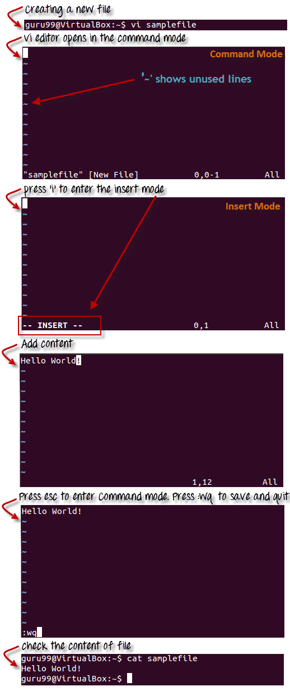

## VI Editing commands

* i - Insert at cursor (goes into insert mode)
* a - Write after cursor (goes into insert mode)
* A - Write at the end of line (goes into insert mode)
* ESC - Terminate insert mode
* u - Undo last change
* U - Undo all changes to the entire line
* o - Open a new line (goes into insert mode)
* dd - Delete line
* 3dd - Delete 3 lines.
* D - Delete contents of line after the cursor
* C - Delete contents of a line after the cursor and insert new text. Press ESC key to end insertion.
* dw - Delete word
* 4dw - Delete 4 words
* cw - Change word
* x - Delete character at the cursor
* r - Replace character
* R - Overwrite characters from cursor onward
* s - Substitute one character under cursor continue to insert
* S - Substitute entire line and begin to insert at the beginning of the line
* ~ - Change case of individual character

**Note**: You should be in the "**command mode" to execute these commands**. VI editor is **case-sensitive** so make sure you type the commands in the right letter-case.

Make sure you press the right command otherwise you will end up making undesirable changes to the file. You can also enter the insert mode by pressing a, A, o, as required.

## Moving within a file

* k - Move cursor up
* j - Move cursor down
* h - Move cursor left
* l - Move cursor right

You need to be in the command mode to move within a file. The default keys for navigation are mentioned below else; You can **also use the arrow keys on the keyboard**.

## Saving and Closing the file

* Shift+zz - Save the file and quit
* :w - Save the file but keep it open
* :q - Quit without saving
* :wq - Save the file and quit

You should be in the **command mode to exit the editor and save changes** to the file.



## Summary:

* The vi editor is the most popular and commonly used Linux text editor
* It is usually available in all Linux Distributions.
* It works in two modes, Command and Insert
* Command mode takes the user commands, and the Insert mode is for editing text
* You should know the commands to work on your file easily
* Learning to use this editor can benefit you in creating scripts and editing files.

# Shell Scripting Tutorial for Linux/Unix Beginners

## What is a Shell?

An Operating is made of many components, but its two prime components are -

* Kernel
* Shell

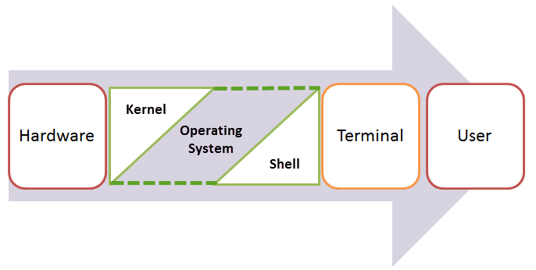

A Kernel is at the nucleus of a computer. It makes the communication between the hardware and software possible. While the Kernel is the innermost part of an operating system, a shell is the outermost one.

A shell in a Linux operating system takes input from you in the form of commands, processes it, and then gives an output. It is the interface through which a user works on the programs, commands, and scripts. A shell is accessed by a terminal which runs it.

When you run the terminal, the Shell issues **a command prompt (usually $),** where you can type your input, which is then executed when you hit the Enter key. The output or the result is thereafter displayed on the terminal.

The Shell wraps around the delicate interior of an Operating system protecting it from accidental damage. Hence the name **Shell**.

In this tutorial, you will learn-

* [What is a Shell?](https://www.guru99.com/introduction-to-shell-scripting.html#1)
* [Types of Shell](https://www.guru99.com/introduction-to-shell-scripting.html#2)
* [What is Shell Scripting?](https://www.guru99.com/introduction-to-shell-scripting.html#3)
* [Adding shell comments](https://www.guru99.com/introduction-to-shell-scripting.html#4)
* [What are Shell Variables?](https://www.guru99.com/introduction-to-shell-scripting.html#5)

<https://youtu.be/9y5TCwVU8iE>

## Types of Shell

There are two main shells in Linux:

**1**. The **Bourne Shell**: The prompt for this shell is $ and its derivatives are listed below:

* POSIX shell also is known as sh
* Korn Shell also knew as sh
* **B**ourne **A**gain **SH**ell also knew as bash (most popular)

**2.** **The C shell**: The prompt for this shell is %, and its subcategories are:

* C shell also is known as csh
* Tops C shell also is known as tcsh

We will discuss bash shell based shell scripting in this tutorial.

## What is Shell Scripting?

Shell scripting is writing a series of command for the shell to execute. It can combine lengthy and repetitive sequences of commands into a single and simple script, which can be stored and executed anytime. This reduces the effort required by the end user.

Let us understand the steps in creating a Shell Script

1. **Create a file** **using** a **vi** editor(or any other editor).  Name  script file with **extension .sh**
2. **Start** the script with **#! /bin/sh**
3. Write some code.
4. Save the script file as filename.sh
5. For **executing** the script type **bash filename.sh**

"#!" is an operator called shebang which directs the script to the interpreter location. So, if we use"#! /bin/sh" the script gets directed to the bourne-shell.

Let's create a small script -

#!/bin/sh

ls

Let's see the steps to create it -

[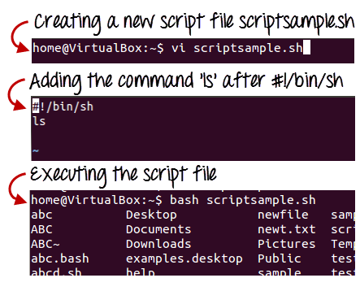](https://www.guru99.com/images/vi_scriptsample(2).png)

Command 'ls' is executed when we execute the scrip sample.sh file.

## Adding shell comments

Commenting is important in any program. In Shell programming, the syntax to add a comment is

#comment

Let understand this with an example.

[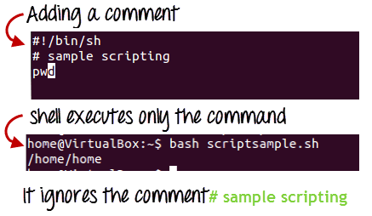](https://www.guru99.com/images/adding_comment.png)

## What are Shell Variables?

As discussed earlier, Variables store data in the form of characters and numbers. Similarly, Shell variables are used to store information and they can by the shell only.

For example, the following creates a shell variable and then prints it:

variable ="Hello"

echo $variable

Below is a small script which will use a variable.

#!/bin/sh

echo "what is your name?"

read name

echo "How do you do, $name?"

read remark

echo "I am $remark too!"

Let's understand,  the steps to create and execute the script

[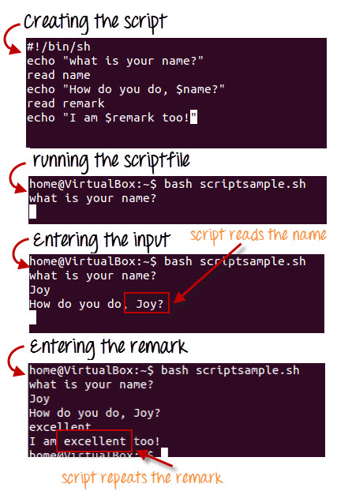](https://www.guru99.com/images/program.jpg)

As you see, the program picked the value of the variable 'name' as Joy and 'remark' as excellent.

This is a simple script. You can develop advanced scripts which contain conditional statements, loops, and functions. Shell scripting will make your life easy and Linux administration a breeze.

[](https://www.guru99.com/images/Shell(1).jpg)

## Summary:

* Kernel is the nucleus of the operating systems, and it communicates between hardware and software
* Shell is a program which interprets user commands through CLI like Terminal
* The Bourne shell and the C shell are the most used shells in Linux
* Shell scripting is writing a series of command for the shell to execute
* Shell variables store the value of a string or a number for the shell to read
* Shell scripting can help you create complex programs containing conditional statements, loops, and functions

# Linux/Unix Virtual Terminal

Linux is a multi-user system, which allows many users to work on it simultaneously. So what if different users need to work on the same system at a time? How do you do that? This is where we need the virtual terminals, let us learn about them.

## What are Virtual Terminals?

Virtual Terminals are similar to Terminal that you have been using so far. They are used for executing commands and offering input. The only difference is that you cannot use the mouse with the Virtual Terminals. Therefore, you need to know the keyboard shortcuts.



Virtual Terminals enable a number of users to work on different programs at the same time on the same computer. This is the reason they are one of the most distinguished features of Linux.

Let us learn how to access and utilize them.

In this tutorial, you will learn-

* [What are Virtual Terminals?](https://www.guru99.com/unix-virtual-terminal.html#1)
* [Starting a Virtual Terminal](https://www.guru99.com/unix-virtual-terminal.html#2)
* [Navigating through Virtual Terminals](https://www.guru99.com/unix-virtual-terminal.html#3)
* [Virtual Terminal shortcuts](https://www.guru99.com/unix-virtual-terminal.html#4)

<https://youtu.be/vAr9PM9dEtE>

## Starting a Virtual Terminal

Usually, there are six (default) virtual terminals on a Linux operating system, and you can log into them as different users to conducts different tasks. The steps to launch a Virtual terminal are:

1) Press Ctrl+Alt+F1

[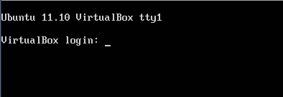](https://www.guru99.com/images/ctrlaltdel.png)

2) Enter User ID and Password

[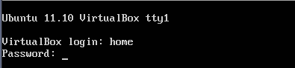](https://www.guru99.com/images/logging_virtual_terminal.png)

3) Now the Virtual Terminal is ready to work on

[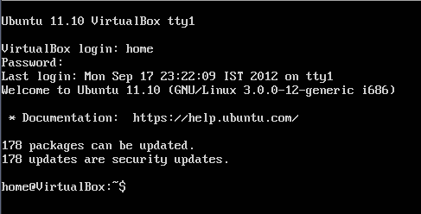](https://www.guru99.com/images/working_on_virtual_terminal.png)

## Navigating through Virtual Terminals

You can navigate between the 6 virtual terminals using the following command.

Ctrl + Alt + F (1 to 6) key

F1 being the first while F6 being the last virtual terminal.

You can work on all of at the same time.

To which virtual terminal you are working on, note **tty** given at the top.

[Unix - Virtual Terminal](https://www.guru99.com/images/tty2.png)

tty is the teletype number which you can also know by typing the command "tty".

[Unix - Virtual Terminal](https://www.guru99.com/images/tty.png)

## The seventh terminal

The seventh terminal is the one which we have been using so for in Linux tutorials. It can be accessed by pressing the below given key combination.

Ctrl + Alt + F7

## ****Virtual Terminal shortcuts****

These are some of the shortcuts that you should be aware of while working on virtual terminals.

|  |  |
| --- | --- |
| **Shortcut** | **Function** |
| Home or Ctrl + a | Move the cursor to the start of the current line |
| End or Ctrl + e | Move the cursor to the end of the current line |
| Tab | Autocomplete commands |
| Ctrl + u | Erase the current line |
| Ctrl + w | Delete the word before the cursor |
| Ctrl + k | Delete the line from the cursor position to the end |
| reset | Reset the terminal |
| history | List of commands executed by the user |
| Arrow up | Scroll up in history and enter to execute |
| Arrow down | Scroll down in history and enter to execute |
| Ctrl + d | Logout from the terminal |
| Ctrl + Alt + Del | Reboot the system |



## ****Summary:****

* Virtual terminals are CLIs which execute the user commands
* There are six virtual terminals which can be launched using the shortcut keys
* They offer multi-user environment, and up to six users can work on them at the same time
* Unlike terminals, you cannot use mouse with virtual terminals
* To launch a virtual terminal press Ctrl+Alt+F(1 to 6) on the keyboard
* Use the same command for navigating through the different terminals
* To return to the home screen of the Linux system, use Ctrl+Alt+F7 and it would take to you the terminal

# Linux/Unix User Administration Tutorial: adduser, usermod, userdel

As Linux is a multi-user operating system, there is a high need of an administrator, who can manage user accounts, their rights, and the overall system security.

You should know the basics of Linux admin so that you can handle the user accounts and usergroups.

In this tutorial, you will learn-

* [Creating a User](https://www.guru99.com/linux-admin.html#1)
* [Deleting, disabling account](https://www.guru99.com/linux-admin.html#2)
* [Adding users to the usergroups](https://www.guru99.com/linux-admin.html#3)
* [Finger](https://www.guru99.com/linux-admin.html#4)
* [Linux/Unix User Management Commands](https://www.guru99.com/linux-admin.html#5)

## Creating a User

In Linux, every user is assigned an individual account which contains all the files, information, and data of the user. You can create multiple users in a Linux operating system. The steps to creating a user are:

### Using Terminal

**Step 1)** Use command sudo adduser

[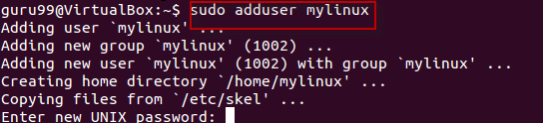](https://www.guru99.com/images/sudo_adduser.png)

**Step 2)**Enter password for the new account and confirm

[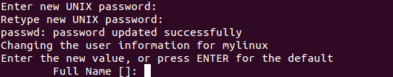](https://www.guru99.com/images/password.png)

**Step 3)**Enter details of the new user and press Y

[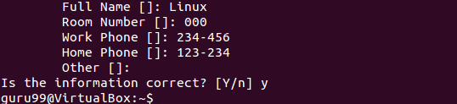](https://www.guru99.com/images/Name.png)

New account is created.

<https://youtu.be/FtwRe8w2kWI>

### Using GUI

**Step 1)** Go to the system settings look for an icon which says 'User Accounts'.

[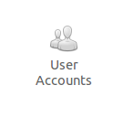](https://www.guru99.com/images/User_Accounts.png)

**Step 2)** Click on the unlock icon and enter a password when prompted, then click the plus sign.

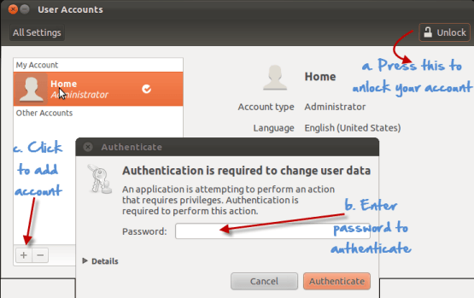

**Step 3)** A new window would pop up, asking you for adding information to the new user account.The account type offers two choices - standard and administration(Ubuntu Limitation). If you want the new user to have administrative access to the computer, select Administrator as the account type. Administrators can do things like add and delete users, install software and drivers, and change the date and time. Otherwise, choose standard.Fill in the full name, username and click on create.

[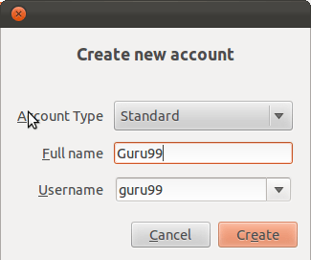](https://www.guru99.com/images/Create_new_account.png)

**Step 4)** The new account would show, but would **be disabled by default.**

**[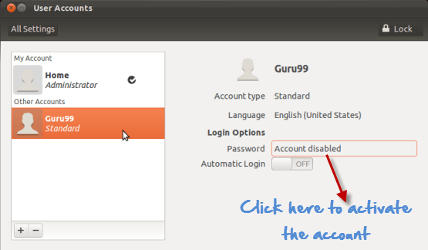](https://www.guru99.com/images/Account_disabled_default.png)**

To activate it, click the password option and add a new password. Click change to enable the account.

**[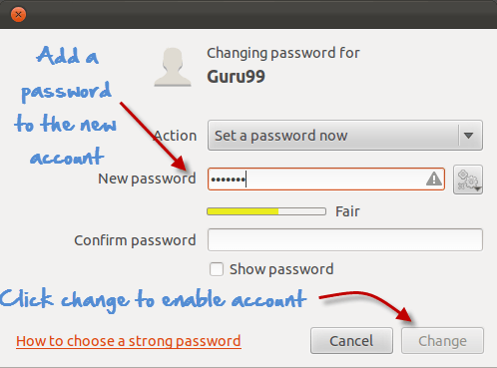](https://www.guru99.com/images/enabling_account.png)**

## Deleting, disabling account

### Terminal

For disabling an account using Terminal, remove the password set on the account.

sudo passwd -l 'username'

**[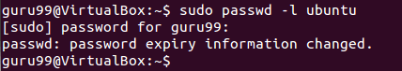](https://www.guru99.com/images/disabling_account_cli.png)**

To delete an account, use the command -

sudo userdel -r 'username'

**[Unix/Linux Administration - adduser, usermod , userdel, finger](https://www.guru99.com/images/deleting_a_c.png)**

### GUI

**Step 1)**Highlight the user account and click the minus sign to delete.

**[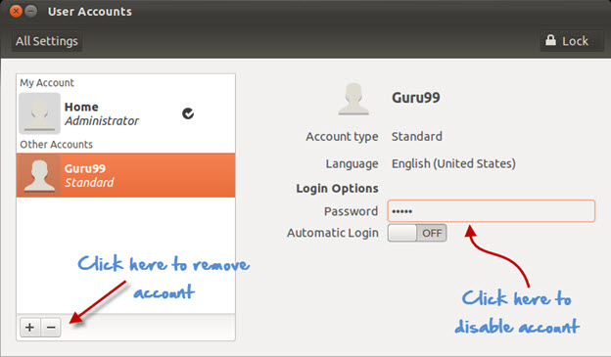](https://www.guru99.com/images/disabling_account_1.jpg)**

**Step 2)**For disabling click on the area where the password is stored, and you would get the following prompt. Select disable this account and click on change.

**[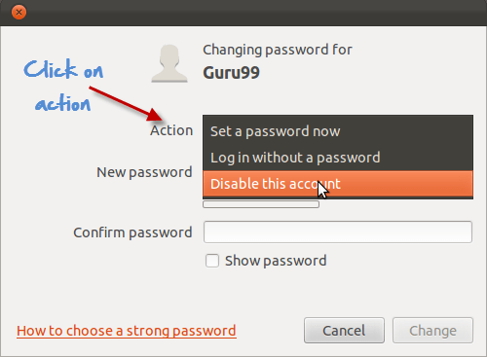](https://www.guru99.com/images/disabling_account.png)**

## Adding users to the usergroups

You can view the existing groups on your Linux operating system by entering the following command:

groupmod "Press Tab key twice"

**[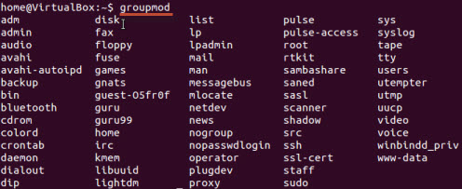](https://www.guru99.com/images/usergroups.jpg)**

Now to add a user to a group, use the following syntax:

sudo usermod -a -G GROUPNAME USERNAME

**[Unix/Linux Administration - adduser, usermod , userdel, finger](https://www.guru99.com/images/adding_user.png)**

The system would ask for authentication and then it would add the user to the group.

You can check whether the user is in a group by this command.

**[Unix/Linux Administration - adduser, usermod , userdel, finger](https://www.guru99.com/images/check_group.png)**

And it would show it as

**[Unix/Linux Administration - adduser, usermod , userdel, finger](https://www.guru99.com/images/show_usergropu.png)**

Removing a user from Usergroup

Use the following syntax for removing a user.

sudo deluser USER GROUPNAME

**[Unix/Linux Administration - adduser, usermod , userdel, finger](https://www.guru99.com/images/sudoDeleteuser.jpg)**

### The GUI method

If you do not want to run the  commands in terminal to manage users and groups, then you can install a GUI add-on .

sudo apt-get install gnome-system-tools

Once done, type

users-admin

Check user settings, and a tab Manage Groups will appear-

**[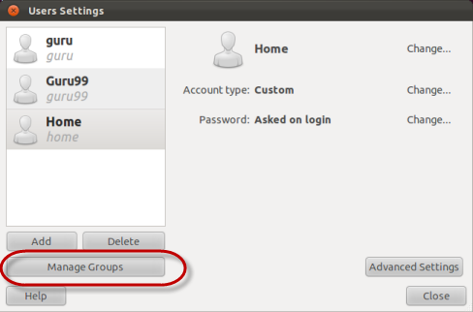](https://www.guru99.com/images/users-admin.png)**

## Finger

This command is used to **procure information of the users on a Linux machine**. You can use it on both local & remote machines

The syntax 'finger' gives data on all the logged users on the remote and local machine.

**[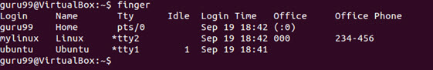](https://www.guru99.com/images/finger.jpg)**

The syntax 'finger username' specifies the information of the user.

**[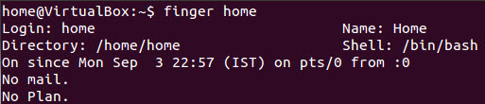](https://www.guru99.com/images/finger_home.jpg)**

## Linux/Unix user management commands

Here is a list of linux user management commands

|  |  |
| --- | --- |
| **Command** | **Description** |
| sudo adduser username | Adds a user |
| sudo passwd -l 'username' | Disable a user |
| sudo userdel -r 'username' | Delete a user |
| sudo usermod -a -G GROUPNAME USERNAME | Add user a to a usergroup |
| sudo deluser USER GROUPNAME | Remove user from a user group |
| finger | Gives information on all logged in user |
| finger username | Gives information of a particular user |

**Summary:**

* You can use both GUI or Terminal for User Administration
* You can create, disable and remove user accounts.
* You can add/delete a user to a usergroup.

# Unix Vs. Linux: What’s the Difference?

## What is UNIX?

The UNIX OS was born in the late 1960s. AT&T Bell Labs released an operating system called Unix written in C, which allows quicker modification, acceptance, and portability.

It began as a one-man project under the leadership of Ken Thompson of Bell Labs. It went on to become most widely used operating systems. Unix is a proprietary operating system.

The Unix OS works on CLI (Command Line Interface), but recently, there have been developments for GUI on Unix systems. Unix is an OS which is popular in companies, universities big enterprises, etc.

## What is LINUX?

Linux is an operating system built by Linus Torvalds at the University of Helsinki in 1991. The name "Linux" comes from the Linux kernel. It is the software on a computer which enables applications and the users to access the devices on the computer to perform some specific function.

The Linux OS relays instructions from an application from the computer's processor and sends the results back to the application via the Linux OS. It can be installed on a different type of computers mobile phones, tablets video game consoles, etc.

The development of Linux is one of the most prominent examples of free and open source software collaboration. Today many companies and similar numbers of individuals have released their own version of OS based on the Linux Kernel.

## Features of Unix OS

* Multi-user, multitasking operating system
* It can be used as the master control program in workstations and servers.
* Hundreds of commercial applications are available
* In its heydays, UNIX was rapidly adopted and became the standard OS in universities.

## Features of Linux Operating System

* Support multitasking
* Programs consist of one or more processes, and each process have one or more threads
* It can easily co-exists along with other Operating systems.
* It can run multiple user programs
* Individual accounts are protected because of appropriate authorization
* Linux is a replica of UNIX but does not use its code.

[](https://www.guru99.com/images/1/053018_0703_UnixVsLinux1.png)

## Difference between Unix and Linux

| **Basis of Difference** | **Linux** | **Unix** |
| --- | --- | --- |
| **Cost** | Linux is freely distributed, downloaded through magazines, Books, website, etc. There are paid versions also available for Linux. | Different flavors of Unix have different pricing depending upon the type of vendor. |
| **Development** | Linux is Open Source, and thousands of programmer collaborate online and contribute to its development. | Unix systems have different versions. These versions are primarily developed by AT&T as well as other commercial vendors. |
| **User** | Everyone. From home users to developers and computer enthusiasts alike. | The UNIX can be used in internet servers, workstations, and PCs. |
| **Text made interface** | BASH is the Linux default shell. It offers support for multiple command interpreters. | Originally made to work in Bourne Shell. However, it is now compatible with many others software. |
| **GUI** | Linux provides two GUIs,viz., KDE and Gnome. Though there are many alternatives such as Mate, LXDE, Xfce, etc. | Common Desktop Environment and also has Gnome. |
| **Viruses** | Linux has had about 60-100 viruses listed to date which are currently not spreading. | There are between 80 to 120 viruses reported till date in Unix. |
| **Threat detection** | Threat detection and solution is very fast because Linux is mainly community driven. So, if any Linux user posts any kind of threat, a team of qualified developers starts working to resolve this threat. | Unix users require longer wait time, to get the proper bug fixing patch. |
| **Architectures** | Initially developed for Intel's x86 hardware processors. It is available for over twenty different types of CPU which also includes an ARM. | It is available on PA-RISC and Itanium machines. |
| **Usage** | Linux OS can be installed on various types of devices like mobile, tablet computers. | The UNIX operating system is used for internet servers, workstations & PCs. |
| **Best feature** | Kernel update without reboot | Feta ZFS - next generation filesystem DTrace - dynamic Kernel Tracing |
| **Versions** | Different Versions of Linux are Redhat, Ubuntu, OpenSuse, Solaris, etc. | Different Versions of Unix are HP-UX, AIS, BSD, etc. |
| **Supported file type** | The Filesystems supported by file type like xfs, nfs, cramfsm ext 1 to 4, ufs, devpts, NTFS. | The Filesystems supported by file types are zfs, hfx, GPS, xfs, vxfs. |
| **Portability** | Linux is portable and is booted from a USB Stick | Unix is not portable |
| **Source Code** | The source is available to the general public | The source code is not available to anyone. |

## Limitation of Linux

* There's no standard edition of Linux
* Linux has patchier support for drivers which may result in misfunctioning of the entire system.
* Linux is, for new users at least, not as easy to use as Windows.
* Many of the programs we are using for Windows will only run on Linux only with the help of a complicated emulator. For example. Microsoft Office.
* Linux is best suitable for a corporate user. It's much harder to introduce in a home setting.

## Limitations of Unix

* The unfriendly, terse, inconsistent, and non-mnemonic user interface
* Unix OS is designed for a slow computer system, so you can't expect fast performance.
* Shell interface can be treacherous because typing mistake can destroy files.
* Versions on various machines are slightly different, so it lacks consistency.
* Unix does not provide any assured hardware interrupt response time, so it does not support real time response time systems.

**Linux Market share compared to other OS**

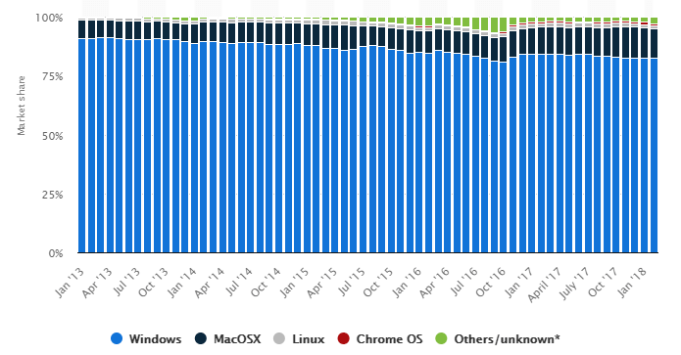

## KEY DIFFERENCE:

* UNIX was released in the 1960s by AT&T bell labs whereas LINUX was developed by Linus Torvalds at the University of Helsinki in 1991.
* UNIX source code is not available to the public while the LINUX source code is available publically.
* UNIX threat detection process is slower whereas UNIX threat detection is faster.
* UNIX is available for PA-RISC and Itanium machines while LINUX is available for Intel’s x86 hardware processors and twenty different types of CPU.
* UNIX different versions are HP-UX, AIS, BSD while LINUX versions are Redhat, Ubuntu, OpenSuse and Solaris
* UNIX is not portable whereas LINUX is portable and can be booted from a USB Stick.

# Best Linux Certifications: RHCE, LPI, CompTIA, Linux Foundation, Oracle

Linux certifications are highly recommended by many companies as Linux gaining recognition by global platforms these days. These certification programs are gaining popularity among data administrators, system admins, DevOps engineers. It helps IT, professionals, to get knowledge and recognition.

In this Linux Certification Tutorial, you will learn:

* [Why Linux Certification?](https://www.guru99.com/best-linux-certifications.html#1)
* [Which Linux certification to choose?](https://www.guru99.com/best-linux-certifications.html#2)
* [RHCE- Red Hat Certified Engineer](https://www.guru99.com/best-linux-certifications.html#3)
* [Oracle Linux Certification](https://www.guru99.com/best-linux-certifications.html#4)
* [LPI Certification Programs](https://www.guru99.com/best-linux-certifications.html#5)
* [CompTIA](https://www.guru99.com/best-linux-certifications.html#6)
* [Linux Foundation](https://www.guru99.com/best-linux-certifications.html#7)
* [Gcux: Giac Certified Unix Security Administrator](https://www.guru99.com/best-linux-certifications.html#8)
* [Advantages of Linux Certifications](https://www.guru99.com/best-linux-certifications.html#9)

## Why Linux Certification?

* Most of the hiring manager are looking to recruit Linux professionals.
* The emergence of open cloud platforms is creating increasing demand for Linux professionals who have the right expertise
* Linux-certified professionals always be a better position in the job market
* Employers are looking for more Linux talent.
* Better salary increments for Linux certified professionals

## Which Linux certification to choose?

There are multiple well-elaborated Linux certification courses available to those professionals who want to recognize and work as a Linux certificate get professional.

Some of the best certification course are given in this article are:

* Red Hat Linux SuSE Linux
* Linux Professional Institute (LPIC)
* CompTIA
* Linux Foundation
* Oracle

## [RHCE- Red Hat Certified Engineer](https://www.redhat.com/en/services/certification/rhce)

[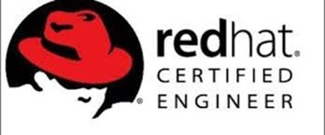](https://www.guru99.com/images/1/092119_0819_BestLinuxCe1.jpg)

Red Hat Enterprise Linux (RHEL) is a Linux distribution system which is developed by Red Hat. This certification program is targeted toward the commercial market.

Red Hat System Administration certification Study Material are designed for IT professionals who don't have previous Linux system administration experience.

|  |  |
| --- | --- |
| **Certification Name** | Red Hat Certified System Administrator (RHCSA) Red Hat Certified Architect (RHCA) Red Hat Certified Engineer (RHCE) |
| **Prerequisites & Required Courses** | Basic technical user skills with handling computer applications and knowledge of some operating systems are expected. |
| **Exam Duration** | 5 hours. |
| **Career Path** | * Linux system administrators * DevOps engineers * Cloud administrators |
| **Cost Per Exam** | $400 each ($2,000 total RHCA exam costs) |

## [Oracle Linux Certification](https://education.oracle.com/oracle-linux/oracle-linux-administration/product_295?certPage=true)

[](https://www.guru99.com/images/1/092119_0819_BestLinuxCe2.png)

The Oracle Linux 6 Certified Implementation Specialist Certification course available for those who design, configure and implement Linux 6 solutions.

However, any applicant can complete this certification. It is mostly achieved by Oracle partner implementation professional who has hands-on experience in Linux and previous experience of implementing Linux 6.

|  |  |
| --- | --- |
| **Certification Name** | Oracle Linux 5 and 6 System Administration |
| **Prerequiesties & Requires Courses** | No prerequisites |
| **Number of Questions** | 80 |
| **Duration** | 150 minutes |
| **Format** | Multiple questions |
| **Passing Score** | 61% |
| **Career Path** | Oracle Linux System Administrator |
| **Cost per Exam** | ₹10,475.00 |
| **Validity** | 5 years |

## [LPI Certification Programs](https://www.lpi.org/our-certifications/lpic-1-overview)

[](https://www.guru99.com/images/1/092119_0819_BestLinuxCe3.png)

Linux Professional Institute (LPI) found in October 1999. After ten years later and after Linus Torvalds began his pioneering efforts on the Linux kernel. It helps software professionals to enhance their Linux knowledge.

|  |  |
| --- | --- |
| **Certification Name** | LPIC-1: Linux Administrator LPIC-2: Linux Engineer LPIC-3: Linux Enterprise Professional |
| **Prerequisites & Required Courses** | * LPIC-1: Fundamental Linux knowledge is required * LPIC-2: Candidate must have an active LPIC-1 certification * LPIC-3: Active LPIC-2 certification plus completion is one of the 300 series specialty exams |
| **Format** | Online |
| **Languages** | English, German, Japanese, Portuguese, Chinese |
| **Passing Criteria** | Passing exams 101 and 102 |
| **Career Path** | Linux Certified Professional |
| **Cost Per Exam** | $200 |
| **Validity** | 5 years |

## [CompTIA](https://certification.comptia.org/certifications/linux)

[](https://www.guru99.com/images/1/092119_0819_BestLinuxCe4.png)

CompTIA Linux+ is a Linux certification course that tests the important usage and managerial activities which are common to all Linux distributors.

To get Linux+ certification, you have to clear these two online tests, which are CompTIA Linux Certification LX0-103 and LX0-104. The course content is very similar to the LPIC-1.

|  |  |
| --- | --- |
| **Certification Name** | CompTIA Linux |
| **Number of Exams** | Two exams: LX0-103 and LX0-104 |
| **Prerequisites & Required Courses** | (LX0-103) - None required (LX0-104)- Recommended: CompTIA A+ CompTIA Network+ and 1 year of Linux administration experience |
| **Format** | Online |
| **Number of Questions** | 60 |
| **Type of Questions** | Multiple Choice |
| **Duration** | 90 minutes |
| **Languages** | English, German, Portuguese, Spanish |
| **Passing Criteria** | 500 (on a scale of 200 to 800) |
| **Career Path** | Network Field Technician   * Network Support Specialist * Network Administrator * Network Analyst * Technical Support |
| **Cost Per Exam** | LX0-103 -$438 total ($219 per exam) [See more prices](https://certification.comptia.org/testing/exam-prices) |
| **Validity** | 3 Years |

## [Linux Foundation](https://training.linuxfoundation.org/certification/linux-foundation-certified-sysadmin-lfcs/)

[](https://www.guru99.com/images/1/092119_0819_BestLinuxCe5.png)

The Linux Foundation Certified System Administrator (LFCS) certification. This certification is best suited for those candidates who want to become Linux system admin pursue their career as a Linux administrator.

The exam has a practical course design which allows a candidate to simulate on-the-job tasks and scenarios faced by a professional system administrator. Obtaining this Linux certification course helps them to check their skills.

|  |  |
| --- | --- |
| **Certification Name** | Linux Foundation Certified System Administrator |
| **Prerequisites & Required Courses** | No prerequisites |
| **Duration** | 2 hours |
| **Exam Format** | Online |
| **Languages** | English, Spanish, Portuguese, Japanese and German |
| **Passing Score** | * LFCS Exam, a score of 66% or above needed * LFCE Exam, a score of 57% or above needed |
| **Career Path** | Linux Foundation Certified Engineer |
| **Cost per Exam** | $300 |
| **Validity** | 3 Years |

## [Gcux: Giac Certified Unix Security Administrator](https://www.giac.org/certification/certified-unix-security-administrator-gcux)

The main motive of attaining this certification program is to train professionals for installing, configuring, and monitoring Unix and Linux operating systems. You can get exam dumps online to practice.

|  |  |
| --- | --- |
| **Certification Name** | GIAC Certification |
| **Prerequisites & Required Courses** | None required |
| **Duration** | 2 hours |
| **Number of Questions** | 75 |
| **Exam Format** | Online |
| **Passing Score** | 68% |
| **Career Path** | Not found |
| **Cost Per Exam** | $1,899 |
| **Validity** | Not found |

## Advantages of Linux Certifications

Here is a prime pros/benefits of using Linux Certification

* Joining Linux Certification program allows you to access to the official training material that helps you to prepare for the exam.
* Offers you a chance to work on real-time projects and demonstrate learning hands-on.
* Helps you to gain concise knowledge of concepts and its applications.
* Support and guidance from industry experts and certified trainers all over the world
* Hands-on Practice and lab sessions which help you clear your concepts in the area of application.

### Summary

|  |  |
| --- | --- |
| **Name of Certification** | **Link** |
| Red Hat Enterprise Linux (RHEL) | <https://www.redhat.com/en/services/certification/rhce> |
| Oracle Linux Certification | <https://education.oracle.com/oracle-linux/oracle-linux-administration/product_295?certPage=true> |
| LPI Certification Programs | <https://www.lpi.org/our-certifications/lpic-1-overview> |
| CompTIA | [https://certification.comptia.org/certifications/linux#examdetails](https://certification.comptia.org/certifications/linux) |
| Linux Foundation | <https://training.linuxfoundation.org/certification/linux-foundation-certified-sysadmin-lfcs/> |
| Gcux: Giac Certified Unix Security Administrator | <https://www.giac.org/certification/certified-unix-security-administrator-gcux> |

# Linux Tutorial for Beginners PDF

Linux is the most popular server OS. Linux is a clone of UNIX. Knowing one is as good as knowing the other. In this ebook, we will be using Linux as it's freely available. The training will require you to execute certain commands. Make sure to practice them!

## Key Highlights of Linux Tutorial PDF are

* 186+ pages
* eBook Designed for beginners
* Beautifully annotated screenshots
* You will get lifetime access

[https://www.guru99.com/images/1/ebook_look_inside.png](https://www.guru99.com/pdf/linux_preview.pdf)

[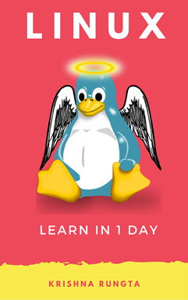](https://www.guru99.com/pdf/linux_preview.pdf)

### Inside this PDF

1. Introduction to the Linux Operating System
2. How to Download & Install Linux (Ubuntu) in Windows
3. Linux vs Windows: What's the Difference?
4. Linux Command Line Tutorial: Manipulate Terminal with CD Commands
5. Basic Linux/Unix Commands with Examples
6. File Permissions in Linux/Unix with Example
7. Input Output Redirection in Linux/Unix Examples
8. Pipe, Grep and Sort Command in Linux/Unix with Examples
9. Linux Regular Expression Tutorial: Grep Regex Example
10. List of Environment Variables in Linux/Unix
11. Linux/Unix SSH, Ping, FTP, Telnet Communication Commands
12. Linux/Unix Process Management: ps, kill, top, df, free, nice Commands
13. VI Text Editor with Commands: Linux/Unix Tutorial
14. Shell Scripting Tutorial for Linux/Unix Beginners
15. Linux/Unix Virtual Terminal
16. Linux/Unix User Administration Tutorial: adduser, usermod, userdel
17. Unix Vs. Linux: What's the Difference?